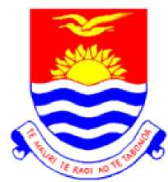

Kiribati Development Plan 2016-19

Government of Kiribati

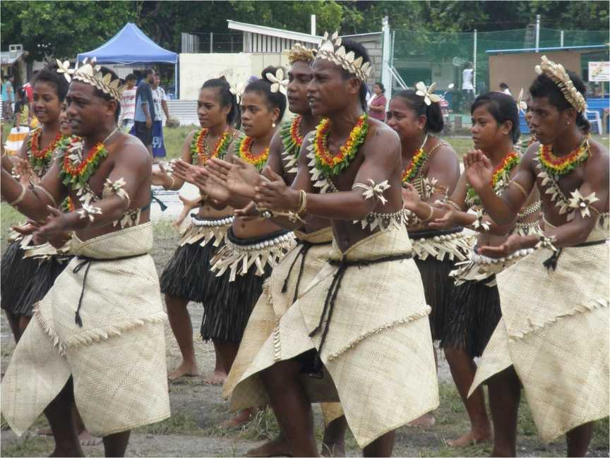

Towards a better educated, healthier, more prosperous nation with a  
higher quality of life

Contents

Acronyms iii

Map of Kiribati v

Foreword 1

Introduction 2

The Vision 4

Guiding Principles of the Plan 5

Review ofProgress ofthe 2012-15 KDP 6

2016-19 Key Priority Area 1: Human Resource Development 15

Situation Analysis 15

Goals and Strategies 19

2016-19 Key Priority Area 2: Economic Growth and Poverty Reduction 22

Situation Analysis 22

Goals and Strategies 27

2016-19 Key Priority Area 3: Health 30

Situation Analysis 30

Goals and Strategies 34

2016-19 Key Priority Area 4: Environment 36

Situation Analysis 36

Goals and Strategies 38

2016-19 Key Priority Area 5: Governance 40

Situation Analysis 40

Goals and Strategies 42

2016-19 Key Priority Area 6: Infrastructure 44

Situation Analysis 44

Goals and Strategies 46

Monitoring and Evaluation for Results 49

1. Country Results Framework for 2016-19 50
2. The Link between the KDP, Sustainable Development Goals, Istanbul Plan of Action, SIDS Accelerated Modalities of Action (SAMOA) Pathway and the Framework for

Pacific Regionalism 66

List of Figures

1. Links between the KDP and Ministry Operational Plans 3
2. Net Enrolment Rates, Primary School, Kiribati, 2011-2014 16
3. Net Intake Ratio, Kiribati, 2011-14 17
4. Proportion of Qualified and Certified School Teachers, Kiribati, 2011 to 2014 18
5. Real GDP per capita, and Real Growth in GDP, Kiribati, 2004 to 2014 22
6. Public and Private Sector KPF Contributors, Kiribati, 2009-2015 23
7. Revenue, Expenditure, Deficits and Surpluses, Kiribati, 2007-2015 24
8. Seamen’s Remittances, 2000 to 2014 25
9. Infant and Under 5 Mortality Rates, Kiribati, 1991 to 2013 30
10. Incidence of TB and Treatment Success Rate, Kiribati, 1990-2014 31
11. Incidence of Diabetes, Kiribati, 2002-14 32
12. Amputations in Kiribati, 2002 to 2014 32
13. New HIV Positive Cases, Kiribati, 1991 to 2014 33
14. Share of Energy Output by Source, Kiribati, 2014 45
15. Solar Connections to Outer Islands, Kiribati, 2004-14 45

**List of Tables**

1. Major Achievements of the 2012-15 KDP 7
2. Official age for school level and total enrolments, Primary School Sector, Kiribati, 2011-2014 17

**List of Boxes**

Box 1: Graduation from Least Developed Country Status for Kiribati 6

Acronyms

|  |  |
| --- | --- |
| ADB AIDS CEDAW CYPFW DCC EEZ ESGBV FDI FFA FNU FSM GBV GDP GNI GOK GPI HICIS HIES HRD ICT JSS KAIP KDP KHIS KIEP KIT KJIP | Asian Development Bank  Acquired Immune Deficiency Syndrome  Convention on the Elimination of all forms of Discrimination against Women  Children, Young People and Family Welfare  Development Coordinating Committee  Exclusive Economic Zone  Eliminating Sexual and Gender Based Violence  Foreign Direct Investment  Forum Fisheries Agency  Fiji National University  Federated States of Micronesia  Gender Based Violence  Gross Domestic Product  Gross National Income  Government of Kiribati  Gender Parity Index  Healthy Islands Core Indicators Set  Household Income and Expenditure Survey  Human Resource Development  Information and Communications Technology  Junior Secondary Schools  Kiribati Aviation Investment Project  Kiribati Development Plan  Kiribati Health Information Service  Kiribati Integrated Environment Policy  Kiribati Institute of Technology  Kiribati Joint Implementation Plan on Climate Change and Disaster Risk  Management |
| KNAO KNSO KOIL KPA KPF KPPS KSEC LDC M & E MCIC MDGs MCIC MCTTD MELAD MFAI MFED MFMRD MHMS MIA | Kiribati National Audit Office  Kiribati National Statistics Office  Kiribati Oil Company  Key Priority Area  Kiribati Provident Fund  Kiribati Police and Prisons Service  Kiribati Solar Energy Company  Least Developed Country  Monitoring and Evaluation  Ministry of Commerce, Industry and Cooperatives  Millennium Development Goals  Ministry of Commerce, Industry and Cooperatives  Ministry of Communication, Transport and Tourism Development  Ministry of Environment Land and Agriculture Development  Ministry of Foreign Affairs and Immigration  Ministry of Finance and Economic Development  Ministry of Fisheries and Marine Resources Development  Ministry of Health and Medical Services  Ministry of Internal Affairs  iii |

|  |  |
| --- | --- |
| MLHRD | Ministry of Labour and Human Resource Development |
| MLPID | Ministry of Line and Phoenix Islands Development |
| MoE | Ministry of Education |
| MOP | Ministry Operational Plan |
| MPWU | Ministry of Public Works and Utilities |
| MS1 | Monthly Consolidated Statistical Report (Health) |
| MTC | Marine Training Centre |
| MWYSA | Ministry for Women, Youth and Social Affairs |
| NCD | Non Communicable Diseases |
| NEPO | National Economic Planning Office |
| NGOs | Non-Government Organisations |
| NIR | Net Intake Ratio |
| OB | Office of Te Beretitenti |
| ODA | Official Development Assistance |
| PHC | Primary Health Care |
| PIFS | Pacific Islands Forum Secretariat |
| PIPA | Phoenix Island Protected Area |
| PNA | Parties to the Nauru Agreement |
| PNG | Papua New Guinea |
| PPP | Public Private Partnership |
| PSO | Public Service Office |
| PUB | Public Utilities Board |
| PVU | Plant and Vehicle Unit |
| RERF | Revenue Equalisation Reserve Fund |
| SDG | Sustainable Development Goals |
| SIDS | Small Island Developing States |
| SPC | Secretariat of the Pacific Community |
| SPREP | Secretariat of the Pacific Regional Environment Programme |
| SOEs | State Owned Enterprises |
| SOIs | Statements of Intent |
| SS | Senior Secondary |
| STAKI | Standardised Tests for Achievement in Kiribati |
| STSISP | South Tarawa Sanitation Improvement Sector Project |
| STR | Student to Teacher Ratio |
| TAFE | Technical and Further Education |
| TB | Tuberculosis |
| TSKL | Telecom Services Kiribati Limited |
| TVET | Technical and Vocational Education and Training |
| UN | United Nations |
| UNESCAP | United Nations Economic and Social Commission for Asia and the Pacific |
| UNDP | United Nation Development Programme |
| UNFPA | United Nation Fund for Population Activities |
| UNICEF | United Nation Children’s Fund |
| VAT | Value-Added Tax |
| WCPFC | Western and Central Pacific Fisheries Commission |
| WHO | World Health Organization |

Map of Kiribati

v

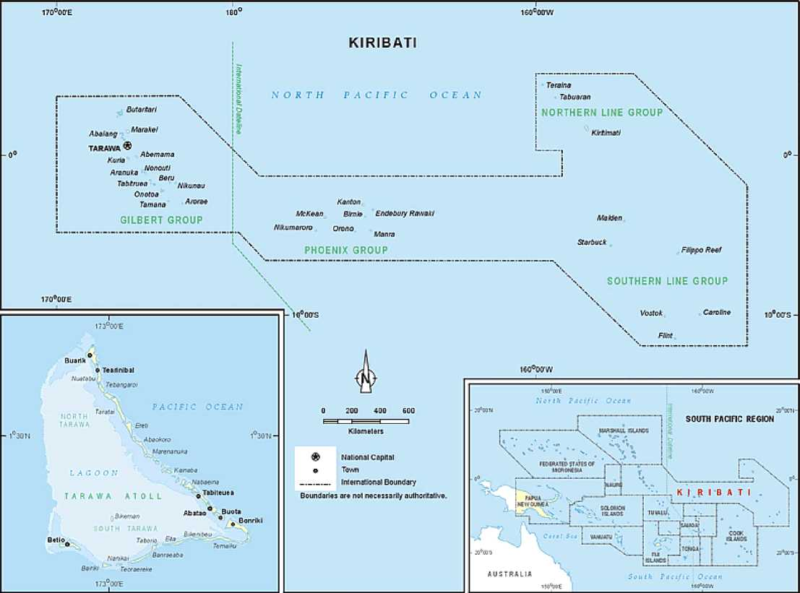

Foreword

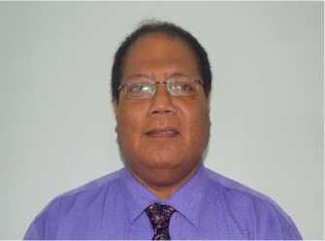Although this is the tenth Kiribati Development Plan (KDP), it is the first development plan of the new government of President Taneti Maamau and his political party, *Tobwaan Kiribati Party* (TKP) following his landslide victory in the nation-wide presidential election on March 9th this year. The Plan emphasises the government’s priorities for development including income generation programs to improve prosperity, better and cheaper education for our students, a healthier community and more job opportunities at home and abroad.

The vision of the Plan “Towards a better educated, healthier, more prosperous nation with a higher quality of life” underlines the typical challenges facing a small island state like ours. The mission of this KDP is to promote better education, better health and inclusive sustainable economic growth and development through the implementation of higher education standards, the delivery of safe, quality health services and the application of sound economic policies.

Essentially, this KDP is a continuation of the predecessor plan with a few adaptations to incorporate the policies of this new government. The Plan focuses on the following six key priority areas (KPAs): Human Resources Development, Economic Growth and Poverty Reduction, Health, Environment, Governance, and Infrastructure which are in line with the TKP *Motinnano* (political manifesto).

The road to economic success is indeed long and hard for us, given the severe resource and structural constraints we face. However, this should not be a cause for despair. The development experience of the more successful small island states elsewhere has indicated that rapid and sustained economic growth and development for the small island states is not a hopeless dream, but an achievable reality provided the right policies and institutions are in place.

In everything we do, we recognize that success is founded on partnership and cooperation. We call upon the international and donor community therefore to continue to support us in our efforts to accomplish the development aspirations of this KDP. As a small developing island nation with limited resources, we simply cannot shoulder our development responsibilities alone.

I urge all stakeholders, the private sector, civil society and churches to work together with Government and to align their development efforts toward achieving this Plan’s objectives and vision. Together we can usher in a new era that is more just, resilient, and inclusive.

Honourable Teuea Toatu PhD

Minister for Finance and Economic Development

Introduction

The Kiribati Development Plan (KDP) for 2016-19 is the guide for formulating policies and programs to advance inclusive economic development in Kiribati. The preparation of the plan has been assisted by the production of Ministry Strategic Plans by each Ministry and agency of the Government. As well, discussions about the nature and purpose of the Plan has occurred with civil society and the private sector. They have also provided feedback on drafts of the Plan. The final Plan has been produced after widespread consultation with the Ministries concerned. The lead Division in the preparation of the Plan was the National Economic Planning Office in the Ministry of Finance and Economic Development. NEPO was ably assisted by Sanjesh Naidu of the Pacific Office of United Nations Economic and Social Commission for Asia and the Pacific (UNESCAP) and Bill Paterson of the Pacific Regional Infrastructure Facility.

The KDP 2016-19 takes into account various international obligations that the Government of Kiribati has assented to. These include the Sustainable Development Goals (SDGs), the Istanbul Plan of Action, the Small Island Developing States (SIDS) Accelerated Modalities of Action (SAMOA) Pathway and the Framework for Pacific Regionalism. Annex B shows the links between these obligations and the KDP. In particular, all SDG targets and indicators have been reviewed and assessed for relevance to Kiribati’s context, including initial country conditions in each Key Priority Area and accounting for progress possible in the four-year timeframe of this Plan. A pathway approach to progressing towards achievement of the SDG’s has been adopted, cognisant of guiding principles underscored in the 2030 UN Development Agenda, namely the need to account for national realities, capacities, levels of development and respecting national policies and priorities.

All projects that are proposed by Ministries, agencies, NGOs and Island Councils have to be aligned with the principles of the KDP. The KDP provides a framework for development so that donors and government agencies have a clear understanding of the policy directions of the Government. The Plan provides an invaluable reference for development partners in aligning their assistance objectives with the priorities of the Government of Kiribati.

Ministry Strategic Plans (MSPs) for the period 2016-19 are aligned with the KDP and provide the guiding framework for each Ministry to focus on technical, administrative and operational strategic issues. MSPs also guide the broad priorities of the KDP in both a top­down and bottom-up approach. Ministerial Operational Plans (MOPs) set out costed activities to progress the MSPs and feed into the budget process for the preparation of the recurrent and development budgets. The links between the KDP and the operational plans and budget are described in Figure 1.

Figure 1: Links between the KDP and Ministry Operational Plans

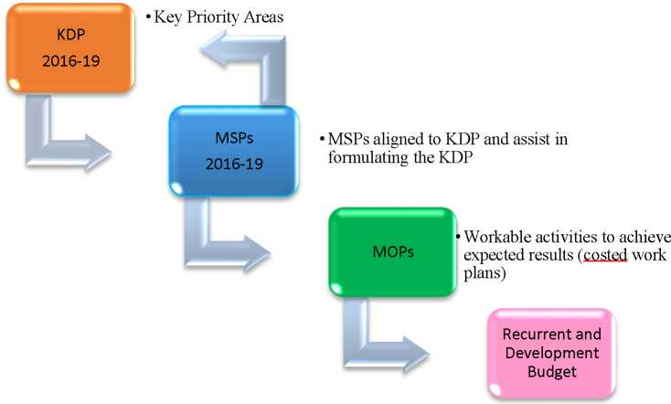

The KDP 2016-19 has also taken into account the Mid-Term Review of the 2012-15 KDP which was undertaken by representatives from the National Economic Planning Office (NEPO), United Nations Development Programme in Asia and the Pacific, (UNESCAP), UNDP Pacific Centre, Secretariat of the Pacific Regional Environment Programme (SPREP), and the Pacific Islands Forum Secretariat (PIFS). Lessons learned from the 2012-15 KDP Mid-term Review have been incorporated into the design of the 2016-19 Plan.

The Country Results Framework (Annex A) outlines the longer-term objectives, strategies and key performance indicators which will form the basis for monitoring the KDP.

The front cover photograph (traditional dancers at the Independence Day celebrations) was taken by Ros Clarke.

The Vision

The vision of the 2016-19 KDP is “Towards a better educated, healthier, more prosperous nation with a higher quality of life’.

This vision encompasses the major goals of providing for a better educated and more highly qualified population to prepare students for future employment, as well as improving the health conditions of the nation and setting the strategies for a more prosperous community.

The mission of the 2016-19 KDP is “To promote better education, better health and inclusive sustainable economic growth and development through the implementation of higher education standards, the delivery of safe, quality health services and the application of sound economic policies.”

The KDP recognises the vital importance of a committed engagement by households, communities, local and national governments, civil society and the private sector towards the future development of Kiribati.

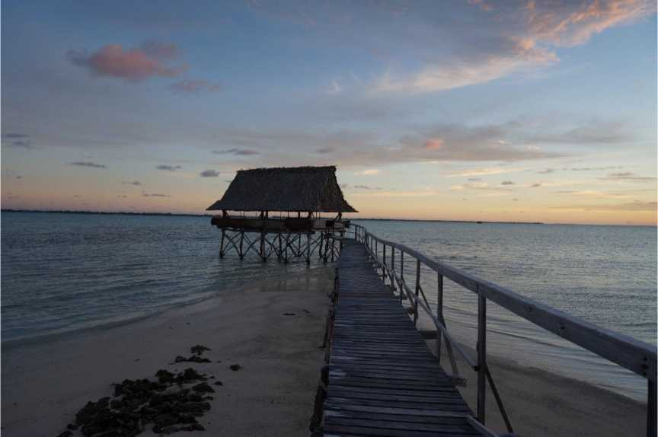

Guiding Principles of the Plan

A number of Guiding Principles will be followed in pursuing the Kiribati Development Plan’s Vision.

Credible national policies and strategies focussed on key underlying areas of priority will drive the KDP’s implementation. Underlying areas of priority (based on Ministry Strategic Plans and consultations) will include:

* Managing population growth;
* Strengthened governance;
* Improved infrastructure;
* Stable macroeconomic framework;
* Economic growth;
* Improved access to basic services;
* Improved health standards;
* Climate change adaptation;
* Improved education standards;
* Reduced poverty;
* Gender equity and the empowerment of women; and
* A clean environment.

Kiribati, as part of the global community, has made commitments within global bodies such as the United Nations, as well as, within regional groupings such as the Pacific Islands Forum. The Government will pursue these commitments in the interest of Kiribati and its citizens, while taking into account national realities, capacities, and respecting national policies and priorities.

Of particular importance are the commitments to the: 2030 Agenda for Sustainable Development that was adopted by the UN General Assembly in September 2015; the Istanbul Plan of Action for Least Developed Countries (LDCs); SIDS Accelerated Modalities of Action (S.A.M.O.A.) Pathway, Outcome of the Third International Conference on Small Island Developing States; and Framework for Pacific Regionalism. These global and regional commitments reinforce and complement Kiribati’s national priorities. The Government of Kiribati is committed to achieving the goals and objectives associated with these international commitments. Where appropriate, policies in this Plan have been made consistent these global commitments. Annex B illustrates how this Plan maps against selected global commitments.

The KDP is also consistent with the Busan Partnership for Effective Development Cooperation which requires, inter alia, ownership of national development priorities and accountability for its implementation.

The means of implementation is a critical challenge in Kiribati. Significant attention to mobilising necessary technical capacity, funding (including through development cooperation) and tailoring institutional arrangements to support the achievement of Key Performance Indicators (KPIs) will remain a key focus of Government.

Review of Progress of the 2012-15 KDP

With 33 coral atolls and islands spanning an area of 3.5 million square kilometres of ocean in the Pacific, Kiribati is constrained by geographic isolation, high transport and shipping costs and a low population base. The very nature of the relative infertility of its coral islands prohibits agricultural production on a large scale. The population in 2010[1] was 103,058 and is spread out over 24 islands.

UNDP Human Development Indicators in 2014 place Kiribati at a low figure of 133 in the country ranking, unchanged from 2013.[2] In 2015, the UN Committee for Development Policy reviewed the status of Kiribati as a Least Developed Country (LDC) and decided not to recommend graduation at this time but to review the situation in 2018, for possible graduation in 2021. The main reason for the decision was the economic vulnerability of Kiribati.

Box 1: Graduation from Least Developed Country Status for Kiribati

The Committee for Development Policy (CDP) of the UN concluded its triennial review of the list of LDCs in March 2015. The Committee found that Kiribati fulfilled the criteria for graduation from least developed country category for the second consecutive time. However, the Committee deferred its decision on a recommendation for graduation for Kiribati to the next triennial review which will be held in 2018. Kiribati was regarded as having the highest level of vulnerability of all countries and there were also concerns about the sustainability of its current level of income. The situation of Kiribati will be reviewed again in 2018.

There are three criteria that the CDP uses for graduation: GNI per capita (averaged over three years) above a certain level; [human resource](http://en.wikipedia.org/wiki/Human_resources) weakness (based on indicators o[f nutrition,](http://en.wikipedia.org/wiki/Nutrition) [health,](http://en.wikipedia.org/wiki/Health) [education](http://en.wikipedia.org/wiki/Education) and adult [literacy)](http://en.wikipedia.org/wiki/Literacy); and economic [vulnerability](http://en.wikipedia.org/wiki/Vulnerability) (based on instability of agricultural production, instability of exports of goods and services, economic importance of non-traditional activities, merchandise export concentration, handicap of economic smallness, and the percentage of population displaced by natural disasters).

For Kiribati to be in a situation to graduate from LDC status, the economic vulnerability criterion will have to be satisfied.

The 2016-19 KDP will address the eight key priority areas of the Istanbul Programme of Action:

1. Productive capacity
2. Agriculture, food security and rural development
3. Trade
4. Commodities
5. Private Sector development
6. Human and social development
7. Multiple crises and other emerging challenges
8. Mobilising financial resources for development and capacity building
9. Good governance at all levels

The population growth in 2010 was 2.2 per cent but South Tarawa’s growth rate was 4.4 per cent compared with 0.2 per cent in all the other islands combined. This growth in South

Tarawa reflects the continual migration of people from the outer islands to the cash economy of South Tarawa. This equates to a doubling by the year 2026 when the population of South Tarawa would be 100,000. This population growth in South Tarawa has placed severe burdens on the supply of basic services such as sanitation and water. Kiribati has adopted a Population Implementation Strategy which promotes healthy family concepts and family planning. The strategy intends to stem outer island migration by improving access to economic and social infrastructure to the outer islands and ensure that all people of Kiribati can access the associated opportunities.

The long term issue that threatens the sustainability of economic development in Kiribati is Climate Change. Kiribati is working with donors to finance adaptation programs which will be vital for a nation with the majority of its land lying just above sea level. Climate Change needs to be acted upon at a global level.

The table below summarises the main achievements of the 2012-15 KDP. Significant improvements occurred with Key Priority Area (KPA) 1 (Human Resource Development), KPA 2 (Economic Growth and Poverty Reduction), KPA 4 (Environment), KPA 5 (Governance) and KPA 6 (Infrastructure). Improvements made under KPA 2 include school enrolment levels which have risen in 2014 and tests for literacy and numeracy had improved from 2011 to 2013. Improvements have been made in health, but Non Communicable Diseases (NCDs), child mortality, maternal mortality and Tuberculosis (TB) remain problem areas.

Table 1: Major Achievements of the 2012-15 KDP

|  |  |  |
| --- | --- | --- |
| **KPA** | **Achievement** | **Comments** |
| **KPA 1: Human Resource Development** | **On Target** | New Act passed by Parliament. Improvements in donor coordination, development of teachers and curriculum. Teacher registration regulations developed. Infrastructure improvements. Level of enrolments the major challenge but improvements have been made in 2014. Standardised tests in literacy and numeracy showed overall improvements between 2011 and 2013. |
| **KPA 2: Economic Growth and Poverty Reduction** | **On Target** | Real economic growth of 5.4%, 5.8% and 2.4% in 2012, 2013 and 2014 respectively. Expectations that growth will continue in 2015. Higher than expected revenue from fishing license fees has meant surpluses in 2013, 2014 and 2015. VAT and Excise taxes introduced and Customs Duties abolished. SOE reforms being implemented. Rationalisation of the copra industry has commenced. TSKL privatised. Still work to do in public financial management. |
| **KPA 3: Health** | **Mixed** | Some progress in key areas. NCDs still a challenge. 12 islands have been declared open defecation free. TB rates still high. Maternal mortality and child mortality rates are still high. More doctors are employed. More doctors have returned after graduation from Cuban |

|  |  |  |
| --- | --- | --- |
| **KPA** | **Achievement** | **Comments** |
|  |  | medical school. Improvements in reproductive health. Infrastructure improvements. |
| **KPA 4: Environment** | **On Target** | PIPA region declared free from commercial fishing from 1 January 2015. Kiribati Joint Implementation Plan on Climate Change and Disaster Risk Management released in August 2014. Kiribati Integrated Environment Policy (KIEP) adopted in June 2013. More mangrove plantings on 9 islands. Improvements in solid waste management made with partner support. More support for agricultural production. Sustainable extraction of construction aggregates established as an enterprise in 2014. |
| **KPA 5: Governance** | **On Target** | The instrument of accession to the UN Convention Against Corruption and the UN Convention on the Rights of Persons with Disabilities signed in September 2013. Greater efforts to counter violence against women. Establishment of a Ministry for Women, Youth and Social Affairs in 2014. Family Peace Bill passed in 2014. Children, Young People & Family Welfare (CYPFW) Act enacted in May 2013. A Climate Change and Climate Risk Communications Strategy 2013-16 developed. Whole-of-Government Communication Strategy adopted in November 2012. |
| **KPA 6: Infrastructure** | **On Target** | Kiribati Roads Rehabilitation Project scheduled to finish in June 2016. Betio Hospital rehabilitation completed in 2014. Betio wharf construction completed in 2014. Kiribati Aviation Investment Project commenced. South Tarawa Sanitation Improvement Sector Project has commenced. Telecommunications Act was passed in 2013 encouraging competition in the communications sector and TSKL was sold to a new operator ATHKL in 2015. Solar projects in the outer islands completed in 2015, providing electricity for villages, small businesses and schools. Two grid-connected solar projects have been completed in 2015 and a third renewables project is in progress, increasing peak power capacity on S Tarawa by 30%. Water resource management and supply efficiency are being improved on S Tarawa, Kiritimati and outer islands. |

The full report on the progress of the 2012-15 KDP can be found on the MFED website[3] as well as the mid-term review of the 2012-15 KDP. The major accomplishments towards progressing the 2012-15 KDP have been:

KPA 1: Human Resource Development

* The Education Act was passed by Parliament in December 2013
* A new language policy was approved by Cabinet in 2012 which transitions from Te- Kiribati to English in Year Three.
* Thirteen Island Education Coordinators were established to support the quality of education in each school on the outer Islands.
* A national curriculum framework has been introduced.
* Improved governance and management, local community involvement, and teacher quality.
* The long term trend of a decline in the net enrolment rate for males and females in primary education was abated in 2014 with high net enrolment rates.
* The transition rates from Primary education to Secondary education in 2014 were reasonably high at 84.4 per cent for males and 90.9 per cent for females.
* Information on the proportion of new entrants requires further investigation as the data varies according to the source for the population base information.
* Standardised tests in literacy and numeracy showed overall improvements between 2011 and 2013.
* In 2014, the vast majority of primary teachers and had the minimum academic qualifications for working as teachers (qualified) but only just over half had attained the minimum teacher training (certified). Overall, approximately two thirds of combined junior and senior secondary, and senior secondary teachers were qualified to teach, while 60 per cent were certified in their respective sectors. On-going initiatives are in place to improve this situation.
* Kiribati has achieved gender parity in primary education. Gender balance in education is an issue in secondary education in Kiribati with the number of female students vastly outnumbering the number of males. For secondary education, total female enrolments ranged from 10 per cent higher in Form 1 to 60 per cent higher in Form 7 in 2014.
* A Technical and Vocational Education and Training (TVET)Strategy has been developed.
* An Auspice Agreement is operating between the Kiribati Institute of Technology (KIT) and TAFE South Australia resulting in all KIT courses having Australian accreditation, with each course needing to meet the standards within the Australian TVET Quality Framework.
* The merger of Kiribati School of Nursing with KIT provided KIT a greater diversity of courses in the health and community services sector as well as the opportunity to establish an additional campus in Bikenibeu.
* In 2015, the Marine Training College (MTC) commenced delivering fisheries training as a result of the merger with the Fisheries Training Centre.
* A Fisheries curriculum was developed in line with traditional overseas employment opportunities as well as emerging ones.
* The establishment of Industry Training and Advisory Committees for KIT and MTC provided opportunities for industry stakeholders to dialogue on training requirements to meet industry demands.

KPA 2: Economic Growth and Poverty Reduction

* GDP growth has been solid over the period of the 2012-15 KDP with growth rates of 5.2 per cent in 2012, 5.8 per cent in 2013 and 2.4 per cent in 2014. The International Monetary Fund (IMF) predicts that economic growth will rise by 3.1 per cent in 2015. This follows a period of volatile fluctuation in growth rates.
* Recent GDP growth has reversed the trend of declining GDP per capita with the GDP per capita at $1,838 in 2014. However, GDP per capita in Kiribati is still the lowest of all Pacific countries.
* The incidence of basic need poverty in Kiribati was estimated at around 21.8 per cent of the population in 2006. No Household Income and Expenditure Survey has been done since 2006. Food poverty was estimated to be around 5 per cent of the population.
* Unemployment at the 2010 census was 31 per cent with the youth unemployment rate at 54 per cent.
* In Kiribati, the private sector is small in relation to the size of government with the geographical isolation and high costs associated with the importation of goods contributing factors. Nevertheless, Kiribati has experienced strong growth in employment in the private sector over the past 6 years. Data from the Kiribati Provident Fund shows that the number of contributors in the private sector has risen sharply from 2,156 in June 2009 to 3,277 in June 2015, a rise of 51.9 per cent.
* Inflation has remained low with rates increasing by 0.6 per cent in 2015.
* Exports are mainly limited to coconut products and fish. Kiribati is highly reliant on imports of foodstuffs. The huge gap between exports and imports remains relatively unchanged. Exports in 2013 were $6.8m while imports were $103.3m leaving a balance of trade deficit of $96.5 million.
* The long term decline in remittances, a customary source of income through seafarers has been reversed in 2015. Further opportunities for overseas employment such as seasonal workers’ schemes in New Zealand and Australia have opened but much more needs to be done here. The White Paper on Northern Australian development opens further potential for low skilled I-Kiribati for future work in Australia.
* On 1 April 2014, the Government introduced a VAT and excise taxes and abolished customs duties.
* The introduction of the VAT and excise taxes will broaden the revenue base and put Kiribati on a more equal footing with the tax structures of other Pacific nations.
* With the introduction of the Vessel Day Scheme, revenue from fishing license fees has increased markedly from $58.3 million in 2012, to $89.0 million in 2013 and $141.6 million. These increased license fees have resulted in Government surpluses in 2013, 2014 and 2015.
* At the end of December 2015, the sovereign wealth fund, the Revenue Equalisation Reserve Fund (RERF), stood at $756.3 million.
* A Private Sector Development Strategy has been finalised.
* A new Telecommunications Act was passed in April 2013. This Act set the conditions for a competitive market in telecommunications and focused on the regulator’s capacity to manage a competitive market. In May 2015, the Government owned telecommunications company TSKL was privatised, and a framework allowing for a second entrant to the market and for providing services to all outer islands is being established.
* A debt policy has also been introduced to strengthen decision-making processes and avoid expensive commercial borrowing.
* Public Financial Management has been strengthened through focusing on accounting and the links between budget and planning.
* Legislation was approved in May 2013 to improve the governance and management of SOEs. The legislation included the following provisions: (a) the commercialisation of SOEs; (b) the establishment of Community Service Obligations; (c) the introduction of Corporate Plans and Statements of Corporate Objectives; (d) independent selection of SOE directors; (e) the establishment of rules for director eligibility to prevent conflicts of interest.
* 87 per cent of listed SOEs have managed to lodge updated financial statements out of

which 64 per cent have lodged 2014 accounts.

* Rationalisation of the coconut industry has commenced
* The new fresh tuna loin processing plant in Betio “Kiribati Fish Limited (KFL)”, with longline fishing vessels, has provided further employment and income opportunities.

KPA 3: Health

* Population growth has been high with a growth rate of 2.2 per cent in the 2010 Population Census. The fertility rate rose from 3.5 in the 2005 population census to 3.8 in 2010 and again to 4.1 in 2011 but there was a decline to 2.7 in 2012. The KDP target for 2015 is less than 3.5.
* The maternal mortality rate rose from 125 in 2010 to 151 in 2014. The KDP target is maternal mortality numbers fewer than two deaths annually by 2015.
* The under 5 mortality rate ranged from 47 to 53 over a four-year period from 2010 to 2013[4]. The KDP target is 22 by 2015. 40 per cent of mothers still give birth outside the public hospital system.
* The ongoing delivery and sustainability of the TB and Leprosy Control Programs are on track.
* The ongoing National Plan for Lymphatic Filariasis and the management of morbidity caused by the disease has been implemented.
* The growth in NCDs is a continuing problem.
* A Bill to strengthen initiatives around tobacco control and alcohol misuse along with the regulations was passed in April 2013.
* Initiatives to prevent and manage diabetes have commenced in South Tarawa.
* Improvements have been made in Mental Health
* Since May 2013, 12 islands have been declared open defecation free.
* Formal training under the Kiribati Internship commenced at the beginning of 2014. The program is intended to provide an internship training program to new medical graduates from the Fiji School of Medicine and Cuba. The return of new overseas trained doctors to Kiribati has boosted doctor numbers, reducing the doctor-patient ratio.
* The implementation of Kiribati National Reproductive Health Policy is underway.
* The Kiribati Child Survival Strategy has been developed.
* The high hospital occupancy rate (above 100 per cent) is an indicator that hospital services are overextended.
* Specialists are still in short supply which has limited the effectiveness and efficiency of health services delivery. However, the number of doctors, nurses and allied health workers are increasing.
* There has been an increase in scholarships for nurses through the TVET programme to support nursing skills upgrades.

KPA 4: Environment

* The Kiribati Integrated Environment Policy (KIEP) was launched in August 2013.
* The Kiribati Joint Implementation Plan on Climate Change and Disaster Risk Management (KJIP) was released in August 2014. The goal of the KJIP is to reduce the vulnerabilities to the impacts of climate change and disaster risks.
* Specialist positions in climate change planning, waste management, and biodiversity conservation have been added.
* The public and local communities have been actively engaged through informal consultations and programmes to raise public awareness on broader environmental issues.
* In August 2013, a Key Biodiversity Area Analysis report, which took stock of the status of national biodiversity, was launched.
* Significant efforts on solid waste management have been made with donor partner support, upgrading three landfill areas, launching private waste collection, and processing e-waste and bulky waste for export.
* The [Phoenix Islands Protected Area](http://www.conservation.org/projects/Pages/phoenix-islands-protected-area.aspx) (PIPA) was closed to all commercial fishing on 1 January 2015. The closure of PIPA will contribute to the conservation and rejuvenation of fish stocks and to food security.
* Efforts have been made to maximise and sustain agricultural production (crop and livestock) at the household level to provide adequate fresh and healthy food and increase household income.
* Environmentally sustainable extraction and processing of construction aggregates has been established through the enterprise Te Atinimarawa Corporation Ltd (TACL) which began operations in late 2014, dredging, excavating and processing coralline material from the lagoon for commercial supply. This aims to protect beach resilience from sand-mining activity and find alternative livelihoods for beach-miners.
* Coastal resilience continues to be improved with further construction of seawalls where appropriate, beach enhancement and expanded planting of mangroves. This is funded under the Adaptation Program, road project and Kiribati Government programs.

KPA 5: Governance

* In September 2013, the Government of Kiribati signed the instrument of accession to the UN Convention Against Corruption and the UN Convention on the Rights of Persons with Disabilities.
* The ratification of the two optional protocols to the Convention on the Rights of the Child occurred in 2014.
* The Kiribati Family Health and Support Study published in 2010 shows that violence against women is prevalent. According to the study, 68 per cent ever-partnered women aged 15-49 reported experiencing physical or sexual violence, or both, by an intimate partner. The Kiribati Government has taken steps to counter these high levels of violence against women including the establishment of a Ministry for Women, Youth and Social Affairs (MWYSA) in 2014.
* The Kiribati Shared Implementation Plan is the overarching 4-year framework to operationalize the Elimination of Sexual and Gender Based Violence in Kiribati.
* The Family Peace Act, which aims to ensure the safety and protection of people, who experience or witness domestic violence, was passed by Parliament in April 2014 and enacted in December 2014.
* Moral Education which is related to eliminating domestic violence has been included in the school curriculum for Year 3 to 6. A network for the safety of domestic violence victims (SafeNet) has been set up in Tarawa and the outer islands
* The Children, Young People and Family Welfare Act was enacted in May 2013.
* The 2nd Universal Periodic Review Report was presented to the UN Human Rights Council in January 2015 and Responses to the UPR Recommendations were presented to the UN Human Rights Council in June 2015.
* A Juvenile Justice Act was passed in August 2015 and enacted in December 2015.
* The Government established the Kiribati National Human Rights Taskforce in July

2014 with a mandate to oversee implementation of all ratified Human Rights Conventions.

* A Whole-of-Government Communication Strategy was adopted in November 2012.
* The Government has developed a Climate Change and Climate Risk Communications Strategy 2013-16 to increase awareness and understanding of climate change and the risks involved.
* The Government is moving to provide enhanced disclosure and publication of government data to ensure the accountability of government to the community.
* The Employment and Industrial Relations Act consolidated three labour laws into one framework (Employment Ordinance, Industrial Relations Act, Trade Union and Employer Organisations Act) and modernised employment practices to keep pace with changing labour market needs and aspirations in Kiribati. This included providing a framework that enables businesses to grow in the context of providing decent work and enable progressive compliance with ratified ILO conventions.
* The Occupational Safety and Health Bill which introduces occupational health and safety in Kiribati was passed in August 2015.
* The Kiribati National Labour Migration Policy was developed and approved by Cabinet towards the end of 2015. The policy provides a coherent strategy and action plan for labour migration from Kiribati.

KPA 6: Infrastructure

* The upgrade to the Port at Betio at a cost of $36.6 million, funded by the Government of Japan, was completed in 2014. It provided an additional 200 m pier length with depth sufficient for medium-size vessels, as well as port handling equipment.
* Reconstruction of South Tarawa’s main road and some feeder and urban roads, funded by the World Bank, Australia and the Asian Development Bank (ADB), is estimated to cost $68 million. Construction commenced in July 2013 and is expected to be completed in early 2016.
* The Kiribati Aviation Investment Project ($29.6 million) will provide upgrades to the runways and airport facilities on Tarawa and Kiritimati islands and reform airport management, funded by the World Bank, New Zealand and Taiwan. The project commenced in 2014 and is expected to be complete by the end of 2016.
* Efforts are in place to improve and upgrade domestic roads and airfields including the outer islands, using funding support from Taiwan.
* The Solar Energy for the Outer Islands project (US$5.3 million), implemented by the Kiribati Solar Energy Company and funded by the European Union, was completed in 2015 providing 2,010 solar home kits, 281 solar kits for maneaba, businesses and teacher residences. Another 8 hybrid mini-grid systems for high schools on 18 islands were installed in 2015 with the EU funding. An additional 10,000 small solar lighting kits were provided with Taiwan funding assistance for delivery and installation on all outer islands. A pricing system aimed at supporting the ongoing maintenance and improved sustainability of these different systems will be explored.
* By 2016 three new solar photovoltaic systems will be connected to the Public Utilities Board (PUB) grid on South Tarawa with an additional peak capacity of 1.4 MW, or 30 per cent of peak demand. A Japan-funded 400 kw system was commissioned at Bikenibeu in April 2015 and a 500 kw system funded by the United Arab Emirates was commissioned at Bonriki in September 2015. A World Bank funded 516 kw system is to be installed on roof-tops at four sites and commissioned by mid- 2016. With automated power management, the systems are expected to provide about 30 per cent of total demand and to save about $800,000 in fuel costs annually.
* Pilot trials of other renewable energy options have been conducted on wind generation, coconut oil biofuel, solar-powered water pumps and hybrid mini-grid systems under Italian funding.
* A Taiwan funded project is on-going to build two steel fuel storage tanks which will give KOIL a 2,000 mt additional fuel capacity.
* The protection of fragile water resources and improvement of fresh water supply has been supported under the coordinated efforts of the World Bank funded Kiribati Adaptation Program Phase III ($10.8 million), Kiriwatsan and the USAID/SPREP support to climate change adaptation initiative. These projects aim to reduce leakage in the transmission main and improve water quality monitoring on South Tarawa, expand rainwater harvesting and groundwater abstraction in North Tarawa and the outer island communities, enhance water security and facilitate sanitation and hygiene improvements in 16 islands, resulting in 12 of them being declared open defecation free by 2015.
* The ADB/Australia South Tarawa Sanitation Improvement Sector Project ($23.7 million) will see the rehabilitation of South Tarawa’s sewer network, saltwater system and ocean outfalls, as well as hygiene awareness programs. Civil works commenced in 2015 and will take two and a half years to complete.

2016-19 Key Priority Area 1: Human Resource Development

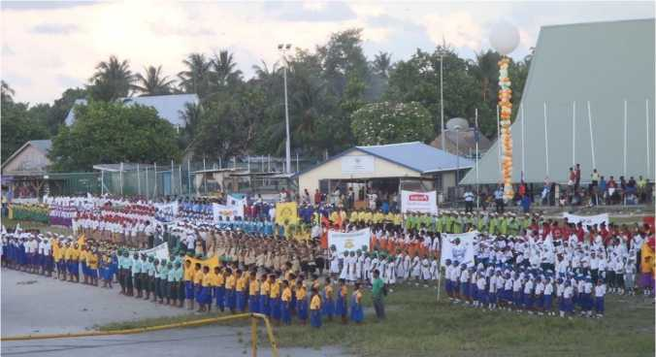

Situation Analysis

A major challenge is the rapidly increasing population and high unemployment rates of youth and school leavers (which are estimated to be at 2,000 per year). The 2010 Population Census showed that unemployment was 31 per cent while youth unemployment was 54 per cent. Female unemployment was 34 per cent and male unemployment 28 per cent while 62 per cent of young women and 48 per cent of young men were unemployed.

The Basic Education system in Kiribati consists of the first nine years of schooling made up of primary school (grades 1 to 6) and junior secondary school (Forms 1 to 3). These years are supplemented by 4 years of senior secondary schooling undertaken in Forms 4 to 7. Only the primary and junior secondary components of schooling are compulsory and free. Basic education is free of school fees and in 2015 the Government approved subsidisation of stationery for students.

A strategy (Education Partnerships in Kiribati) has being developed to enhance engagement with development partners and other Ministries.

Most post school education (including TVET) is under the management of the Ministry of Labour and Human Resource Development (MLHRD). This education activity is provided by the Kiribati Teachers College (managed by MoE), KIT, MTC (now amalgamated with the Fisheries Training Centre), Kiribati Nursing College, and the Police Training Centre. The Kiribati Teachers College, managed by MoE, is an important exception. It provides pre­service programs for the nation’s teachers.

A commitment by the Government to inclusive education and to early childhood education has evolved recently. As well, educators see that recent Information and Communication Technologies (ICT) development will have transforming impacts upon learning and curriculum reform. The Government has placed emphasis on increased skills and capacity of teachers***.*** This growth in capability comes from more support for professional development and from the efforts and attributes of teachers themselves. The proposed introduction of regulations for teacher registration will enhance this move towards professional development.

The 2015 Millennium Development Goals related to education will not be achieved. This in particular relates to enrolment rates and survival rates to Class 5.

There is some conjecture as to the accuracy of statistical data for education. The information shows that a key performance indicator, the Primary Education Net Enrolment Rate, has been declining in recent years but 2014 has seen a reversal in this long term decline (see Figure 2). Anomalies in projections of the population of Kiribati from the 2010 Census have resulted in the decision to include projections from two regional authorities, UNDP, labelled ‘Population 1’ and SPC, labelled ‘Population 2’. These projections provide upper and lower range estimates within which true population values may lie.

Figure 2: Net Enrolment Rates, Primary School, Kiribati, 2011-2014

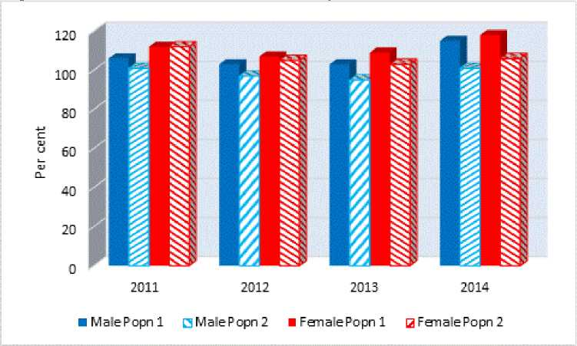

Source: MoE

Primary school enrolments declined gradually from 18,138 in 2005 to 16,710 in 2013. In contrast, there were an additional 1,498 enrolments in 2014 (a 9 per cent annual increase). This increase occurred across all four educational districts.

Enrolments within the official age range (6 to 11 years) and total enrolments for the primary school sector were lower in 2012 and 2013 than in 2011, then increased significantly in 2014 (Table 2).

The gender parity index (GPI) measures the ratio of females to males for a given indicator. The GPI for enrolments in Kiribati indicates that enrolment rates were consistently higher for girls compared with boys across the four-year period.[5]

Table 2: Official age for school level and total enrolments, Primary School Sector, Kiribati, 2011-2014

|  |  |  |  |  |
| --- | --- | --- | --- | --- |
| **Age Group** | **2011** | **2012** | **2013** | **2014** |
| **6 to 11 years** | 14,118 | 13,406 | 13,460 | 14,751 |
| **Total enrolments** | 15,468 | 14,990 | 14,697 | 16,194 |
| **Gender Parity Index** | 1.08 | 1.06 | 1.07 | 1.04 |

Source: KEMIS, MoE, 2015

The Net Intake Rate (NIR) shows the number of new entrants into class one primary who start school at the official primary school start age (six years old) expressed as a percentage of the total population of official primary school entry aged children.

The information is sketchy depending on the population base used. With the UNDP population base, the proportion of new entrants has risen since 2011 when 100.6 per cent of males and 96.8 per cent of females were new entrants. In 2014, the figures had slightly declined to 100.4 per cent for males but rose to 102.3 per cent for females. Using the SPC population data base, the figures had declined from 91.8 per cent in 2011 to 77.5 per cent in 2014 for males and 91.6 per cent in 2011 to 78.1 in 2014.

Figure 3: Net Intake Ratio, Kiribati, 2011-14

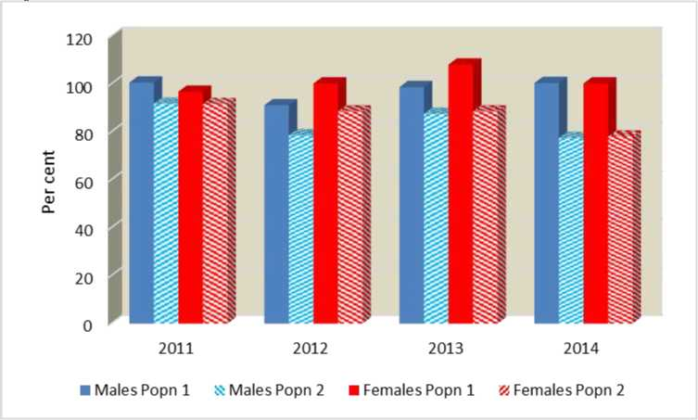

Source: MoE

Progression (survival) to Class 5 was marginally higher in 2014 than 2011 (76 per cent vs 74 per cent). There was no change in Class 6 survival rates between 2011 and 2014, which remained stable at approximately 70 per cent.

Performance tests in literacy and numeracy showed improvements between 2011 and 2013. The participation rate for girls exceeds that of boys in Junior Secondary School (JSS) and Senior School (SS), and the gap is widening.

The transition rates from Primary education to Secondary education in 2014 were high at 84.4 per cent for males and 90.9 per cent for females, giving a total of 87.6 per cent.

The minimum academic qualifications required by national authorities for teachers is Form 5 for Primary Teachers and Form 7 for Junior and Senior Secondary Teachers. Certification requires a two year teaching certificate. The trend appears to be showing an overall improvement in the qualifications of teachers in Kiribati schools.

Figure 4: Proportion of Qualified and Certified School Teachers, Kiribati, 2011 to 2014

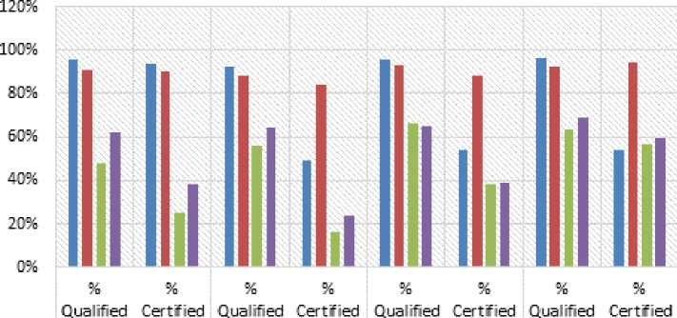

2011 2D12 2013 2014

■ Primary BJSS ■ Combined JS Schoo! ■ SSS

Source: MoE

Student to teacher ratios (STR) were highest in the primary school sector and increased from 23.3 to 26.4 students per teacher between 2012 and 2014. In 2014, STR was lowest for junior secondary schools at 15.6 students per teacher, while STR’s for combined junior/senior secondary schools and senior secondary schools were slightly higher at 17.4 and 17.7 respectively.

The emerging curriculum and assessment development process, modernisation of school facilities and the emphasis on teacher development and school improvement processes should assist in addressing these issues.

Kiribati has been participating in seasonal work schemes in Australia and New Zealand. Though participation has been relatively low compared to other Pacific Islands, 2015 saw new developments in efforts to increase Kiribati’s participation in unskilled and low skilled employment and labour migration opportunities including the NZ Fisheries Pilot Project and the Northern Development White Paper for Australia which will allow extended visas for low skilled workers from select Pacific countries including Kiribati. As well, conditions have been applied to the issuance of fishing licenses to increase employment opportunities.

Seafaring has been a main source of employment and income in Kiribati. Seafarers trained at the MTC have for many decades been contributing to the economy through remittances. In 2015, MTC commenced delivering fisheries training as a result of the merger with the Fisheries Training Centre.

The KIT has also invested heavily in developing a strong and positive brand within the Kiribati community. This has resulted in KIT being recognized as a high quality TVET 18

institution, allowing KIT graduates to receive preferred employment opportunities from local and international companies operating in Kiribati. A key strength of KIT is its ability to offer international standard TVET courses through partnerships with TAFE South Australia, TAFE Queensland East Coast and Fiji National University (FNU). However, poor access, performance, reliability and the high cost of internet connectivity impacts negatively on KIT teaching and administration. Although KIT has achieved significant reforms in workplace behaviour and productivity, the performance of some staff needs to be raised to maintain KIT’s strong brand attributes and provide the necessary mentoring and role models for KIT students and graduates.

Goals and Strategies

Education is a key priority for the development of Kiribati. Having citizens with strong literacy and numeracy skills is the cornerstone of developing a contemporary workforce with the ability to compete internationally and ultimately be in a position to capably mobilise to meet the demand for skills in neighbouring developed countries such as New Zealand and Australia.

While there has been considerable improvement in retention and student performance, there is scope for further improvement and these continue to be the major focus of MoE planning. This has been accompanied by strengthening of the curriculum, now being extended into JSS, and by a strong emphasis on developing both the skills and professionalism of teachers. These emphases will continue into the next planning cycle and will be accompanied by a major initiative in educational leadership.

Initiatives to strengthen English language skills will continue, especially for those students who wish to further their education at overseas institutions and for those teachers seeking professional registration. Evidence of English language proficiency will be a mandatory requirement for proposed regulations for teacher registration.

Investment in associated infrastructure and resources is necessary to foster a conducive learning environment where students are physically and emotionally safe will continue, ensuring that all students have access to the basic facilities and resources needed to achieve improved learning outcomes. Maintenance of existing facilities to preserve standards will be continued.

In addition to quality education and training, there is also a need to focus on inclusive national sport development from grass-roots to the elite level. All strategies to develop and implement national sports at all levels shall be form part of a newly established National Sport Policy.

Goal 1: Improve the quality of education and training to provide students with the skills and capability to progress to a productive future.

Strategies:

* Lift enrolment and participation of 6 year olds in Year Isubstantially through promotion of successful early engagement in learning as a critical foundation for further learning.
* Establish a more explicit and sustained focus on the teacher skills needed to transform literacy and numeracy achievement levels in Primary School.
* Support skills development amongst teachers and increasing the professionalism of each teacher through lifting teacher competencies to meet internationally recognized Teacher Service Standards and implement the Teacher Registration Process as part of strengthening professionalism.
* As the critical foundation for ongoing learning and development, accelerate the transition into English in Primary and Junior Secondary School.
* Priority will be given to the further implementation of the National Curriculum and Assessment Framework, setting of national benchmarks, providing curriculum resources and writing of a new syllabus.
* Implement a strategy to integrate emerging developments in ICT into curriculum and school operations.
* Provide healthy and safe school buildings and facilities by reviewing and refocussing the school rehabilitation program in consultation with the Facilities Management Unit and stakeholders.
* Secure ongoing funding for the delivery of the Primary School and Junior Secondary School (JSS) facilities maintenance schedule.
* Effectively implement the Inclusive Education Policy to target children with disabilities and communicate and gain community acceptance of the policy of mainstreaming children wherever appropriate. Also strengthen teacher capabilities to teach to more diverse learning needs and design and develop a supportive and enabling operational environment.
* Complete and implement the regulations flowing from the Education Act 2013.
* Foster the development of early childhood education through support for the development of an appropriate legislative framework and the development of a supportive operational environment.
* Strengthen further collaborative mechanisms for MoE engagement with government agencies and other non-government education sector stakeholders.
* Strengthen and enforce TVET quality standards so that TVET providers meet regional and international standards including accreditation of KIT with Pacific Regional Qualification Framework
* Improve access and entry opportunities for I-Kiribati into TVET programmes and qualifications through a range of strategies including the development and implementation of an Outer Island and Kiritimati Island strategy and identify opportunities for skills testing and gap training for existing workers.
* Diversification of TVET training to match industry needs.
* Rehabilitation of KIT Bikenibeu Campus
* Strengthening Government’s workforce capacity to meet the demands for the Government’s services through training programs for employees.
* Sustaining cultural skills and knowledge though promotion of cultural activities.
* Establishment, endorsement and implementation of the National Sport Policy.

Key Performance Indicators:

For each of the following key performance indicators, a major review of their status will be undertaken in 2016 to establish existing rates accurately. These results will form the benchmark for targets set for the period to the end of2019.

1. The target for net enrolment rate for males and females in primary education is 100%.
2. The target for the Net Intake Rate (proportion of new entrants into class one primary) is 100% for males and females
3. The target for the Survival Rate for Class 5 is 100% for males and females
4. The target for the Transition Rate from Class 6 to Form 1 is 100% for males and females
5. The proportion of teachers having the required minimum qualification to teach is raisedto 100%
6. Student teacher ratios in primary education to be reduced to 20.
7. Proportion of students performing at or above the STAKI expected level is raised to 60% in English, 70% in Te-Kiribati and 60% in Numeracy for Class 4 students and 60% in English, Te-Kiribati and Numeracy for Class 6 students.
8. 50% of students with disability enrolled in mainstream schools
9. 50% of students enrolled in Early Childhood Education
10. An increased number and proportion ofKIT students complete their training and gain international quality assured qualifications.
11. Officer of the Watch training introduced
12. Training in port operations undertaken
13. Percentage increase in the number of qualified employees in the public service.
14. The establishment, endorsement, and implementation of the National Sport Policy.

2016-19 Key Priority Area 2: Economic Growth and Poverty Reduction

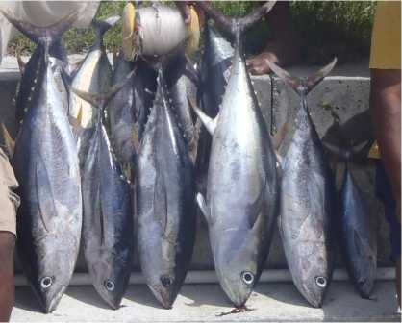

Situation Analysis

While economic growth has fluctuated wildly in the 2000s, by 2012 and 2013, real rates of GDP growth had risen by a high 5.2 per cent and 5.8 per cent respectively (Figure 5). This was followed by solid growth of 2.4 per cent in 2014. GDP was $206.4 million in 2014 but GDP per capita was only $1,838, among the lowest of all Pacific countries. Poverty and hardship are widespread with 21.8 per cent of the population under the Basic Needs Poverty Line in 2006[6]. Poverty is highest in South Tarawa (22.4 per cent) and lowest in the Line and Phoenix Islands (8.9 percent). Despite the high rates of poverty, expenditure below the basic needs food poverty line was only 4.9 per cent of the population with a low rate of .05 per cent for the Line and Phoenix islands.

General population health issues are contributing to loss of productivity, and increasing marginalisation and vulnerability. Environmental factors, including the challenge of climate change, and agricultural food production, impact people’s daily lives and well-being.

Figure 5: Real GDP per capita, and Real Growth in GDP, Kiribati, 2004 to 2014

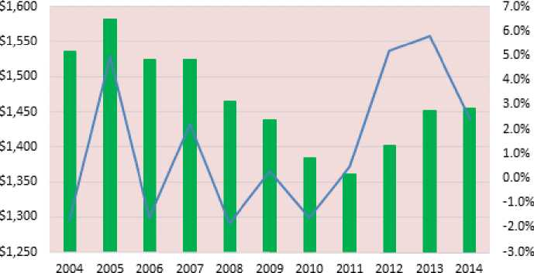

Rea! GDP per capita —— Rea! GDP growth rate

Source: KNSO

The Gini Coefficient of 0.39 per cent[7] suggests that income inequality in Kiribati is about the average of other Pacific nations. This most likely reflects the high level of subsistence living in the country.

Unemployment[8] is high with 30.6 per cent unemployed in 2010 but 57 per cent of the population are under the age of 24 and youth unemployment at 54 per cent is a cause for concern.

Kiribati Provident Fund information (Figure 6) shows that private sector employment has significantly risen in recent years. The number of KPF contributors in the private sector rose sharply from 2,156 in June 2009 to 3,277 in June 2015, an increase of 51.9 per cent. In the public sector, comparable figures were 7,027 for 2009 and 6,736 for 2015. While non­compliance means that not all private sector employees are covered by the KPF, the government employment data is in line with the 2010 Population Census information.

Figure 6: Public and Private Sector KPF Contributors, Kiribati, 2009-2015

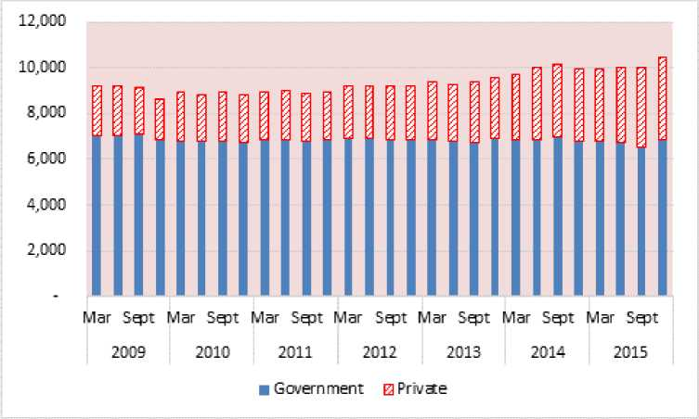

Source: KPF

The Seasonal Workers Schemes in New Zealand and Australia have successfully contributed towards a more mobile labour force again returning remittances. However, more work, including robust marketing strategies, needs to be undertaken to increase the volume of seasonal workers from Kiribati. Work is also needed on programs such as financial literacy training to ensure that workers can derive the maximum benefits from such schemes.

With income from fishing licenses accounting for the majority of government income for some time, an emphasis on economic reform has been made to increase taxation revenue and thus broaden the revenue base. On 1 April 2014, VAT and an Excise Tax were introduced and Customs Duties were abolished. The effects of this new arrangement will see taxation revenue climb from $29.6 million in 2013 to an estimated $35 million in 2015. The imposition of the VAT should also arrest the trend of non-compliance in company tax over the past few years.

Due to a record income from fishing licenses in 2013, Kiribati posted a surplus of $21.2 million compared to a deficit of $16.0 million the previous year (Figure 7). This was the first surplus recorded in Kiribati since 1998. In 2014, Kiribati also experienced a surplus of $67.6 million and expected another surplus of $117.2 million in 2015. While Government spending has increased in recent years the amount is significantly below revenue which has been a substantial change from conditions prior to 2012.

A new national fisheries strategy together with regional agreements have assisted the revenue from fishing licenses. Currently, the weather patterns are for an El Nino effect which commenced late in 2014 and is now at record levels. The El Nino brings warmer waters to the Pacific and higher fishing catches in Kiribati. However, catches will drop with changes in weather conditions so that Kiribati needs to ensure a more sustainable and stable level of income continually flows into the country.

Figure 7: Revenue, Expenditure, Deficits and Surpluses, Kiribati, 2007-2015

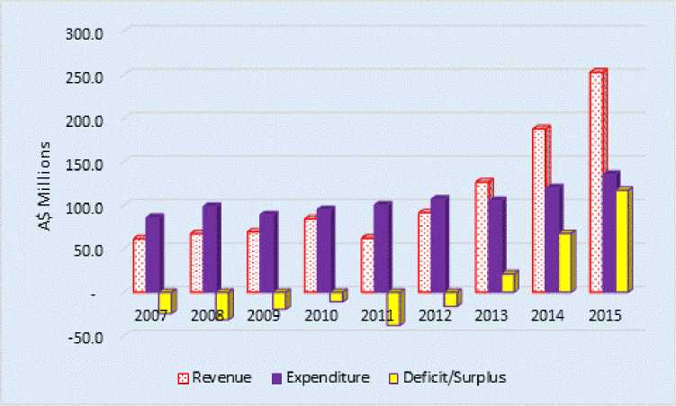

Source: MFED

With export markets limited to coconut products and fish, exports have traditionally been very low in Kiribati around $7 million annually while imports are around the $100 million mark, predominantly foodstuffs. The low export trends are attributed to limited product varieties and supply capacity.

Inclusive socio-economic development can only be realised when outer islands are developed and when a trading environment is encouraged. Economic activities have developed substantially in Tarawa within the last planning period. The outer islands however, remain economically underdeveloped.

Kiribati has very limited land and agriculture resources. The soils are shallow, alkaline and very low in organic matter content while water sources are mostly fragile shallow water lenses that are susceptible to salt water incursion due to over-use, drought and sea level rise. The distance between the islands increases the complexities in the working environment, which is coupled with the poor means of communication to monitor the progress of activities.

Most agricultural food production (crops and livestock) is at subsistence level, while there have also been initiatives and commercial programs operating on a very small scale that have provided local markets with eggs, vegetables and other small farm products.

Remittances have been a large source of overseas income in the past. In 1990, a period when there were a high number of overseas seafarers compared to the total population, remittances amounted to 18 per cent of GDP[9]. In 2014, the figure had slipped to 9.6 per cent of GDP. This compares with 18 per cent in Samoa (2014) and 28 per cent in Tonga (2013). This change in Kiribati in more recent years can be attributed to the Global Financial Crisis, changes in vessel technology with larger ships, and increased competition from Asian nations. Lower amounts of seafarers’ remittances have been occurring for a number of years, but particularly from 2007 during the Global Financial Crisis (see Figure 8). This negative growth was reversed in 2015.

Figure 8: Seamen’s Remittances, 2000 to 2014

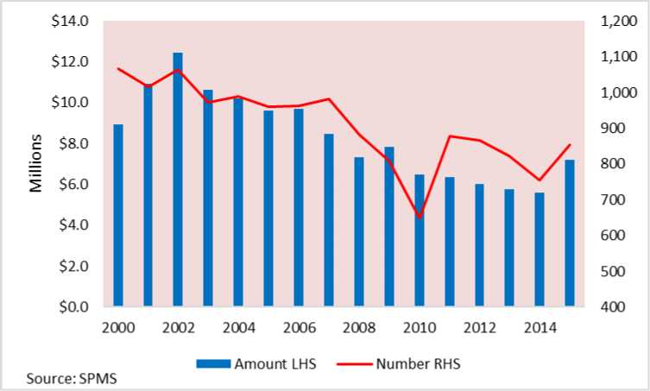

The program of State Owned Enterprise (SOE) reform, has been embarked upon to improve the financial viability and management of SOE operations. A new SOE Act was introduced in 2013 which provided for placing our SOEs on a more business oriented footing. SOEs have to provide Statements of Intent to outline their business plans for the future. Community Service Obligations are being paid to some SOEs to maintain low prices for some essential services. For the first time the Government has entered into a Public Private Partnership with the new management of the Otintaai Hotel. Non-performing SOEs have been dismantled. Legislation has also been introduced to liberalize the telecommunications sector.

A new policy on the management of public sector debt has been adopted. This policy has meant that the Government will no longer enter into non-concessional loans which have been a drain on Government funds in the past.

While the public sector remains relatively high as a proportion of GDP, the Government has been promoting private sector growth through a Private Sector Development Strategy. The key challenge facing private sector development is the existence of outdated business laws which are not compatible with the current trade and development regime. This strategy intends to create an enabling environment for private sector growth by reviewing outdated business laws and to effectively implement the enacted business related laws to support the establishment of new businesses and overall growth of the private sector in Kiribati.

The Kiribati sovereign wealth fund, the Revenue Equalisation Revenue Fund (RERF) was capitalised through the proceeds of phosphate mining which ceased in 1979. The RERF plays two key roles. First, it serves as a capital base preserved for future generations.

Secondly, it provides a financing function for recurrent deficits. At the end of 2015, the fund was $756.3 million, the largest sovereign wealth fund in the Pacific.

Whereas there are financial institutions providing credit to the business community in Kiribati, access to affordable credit by small businesses still remains a challenge to entrepreneurship and business development. Constraints in accessing finance is attributed to strict collateral requirements as a security by the mainstream lending institutions.

Lack of a coherent trade and investment policy framework creates unpredictability in the business environment, which constrains the growth of trade and investment in Kiribati. While legislation exists to monitor the development of cooperatives in Kiribati, their full potential in fostering sustainable economic development is yet to be harnessed due to the lack of a national policy to guide the conduct of co-operative development.

Donors have played a large part in assisting with development in Kiribati through several means including soft loans, bilateral grants and regional programs. In 2014, the amount provided in official development assistance was $105 million compared with the recurrent government expenditure of $135.7 million. In 2014, for the first time, Kiribati received $10.4 million from the World Bank, the ADB and New Zealand in budget support.

Collection of statistics needs to be enhanced to ensure that up-to-date data is available to make informed management decisions. Public dissemination of statistics also requires better centralised information systems. Fisheries management information (from surveys, fishery statistics, development activities, and other sources) is difficult to access because of inadequate library records, out-dated statistics collection methods, and poor reporting.

Fisheries information is not currently organized in a manner that would support island by island resource assessments and island-based fisheries management plans.

Goals and Strategies

Solid and sustainable economic growth is the way to move people out of poverty and provide the necessary employment for the economic betterment of the population. Inclusive economic growth so that the more vulnerable groups are not disadvantaged is the overall aim. Acceleration of private sector employment through various policies to enhance private sector development is also a high priority. Further improvements in the management of State Owned Enterprises will assist with the aim of having SOEs operating on a more commercial footing.

**Goal 2: To enhance inclusive economic development through improving and increasing sustainable employment, financial inclusion for vulnerable groups, structural and fiscal reforms and accelerating private sector development.**

Strategies

* Support policies to raise income levels through various means including enhancing overseas employment opportunities to promote stronger growth in remittances; increasing domestic production especially in the outer islands through strengthening existing industries and promoting new industries to boost domestic and external trade.
* Provide sustainable development of the fishing industry and maximize economic returns from marine resources.
* Create employment opportunities through crewing arrangements with shipping companies and establishment of onshore development of fisheries resources.
* Strengthen fishery and catch management data.
* Promotion of private sector development including enhancing opportunities for external investors and reform of business law to create a conducive business environment.
* Strengthen and implement alternative business financing mechanisms to improve access to finance especially for Small and Medium-sized Enterprises as envisaged in the Private Sector Development Strategy.
* Formulate and effectively implement an Integrated Investment Policy Framework that supports the government business reform agenda and improves foreign investment opportunities in Kiribati. Specifically, business law reform will improve the ease of doing business in Kiribati.
* Maintain and build on social security mechanisms to ensure that the most vulnerable, particularly those that suffer from disasters and climate related extreme events, are cared for.
* Increase taxation and customs revenue through a range of initiatives including increasing the quality of VAT returns; reducing business and company tax arrears through better compliance and record keeping; self-assessment for business and company tax; and reviewing customs regulations.
* Establish effective financial public administration including improvements in the forecasting of taxation revenue and expenditure for the annual budget; and conducting reviews of internal processes to raise efficiency.
* Establish effective debt management controls including ensuring debt levels are sustainable; and monitoring and ensuring that the debt management policy is adhered to.
* Place State Owned Enterprises on a more commercial footing including the completion of the rationalisation of the coconut industry; rationalise at least two other SOEs including activities such as privatization, Public Private Partnerships (PPP), mergers or contracting out services; the production of annual Statements of Intent (SOIs) by all SOEs and the production of timely half yearly and annual reports by all SOEs.
* Enhance the collection and availability of statistics through the implementation of a National Strategy for the Development of Statistics. This will include a centralised national statistical website; undertaking a Household Income and Expenditure Survey; conducting the analysis of the 2015 Kiribati Population Census; compiling trade data; undertaking a Demographic and Health Survey; improving the data collection and management from Birth, Marriage and Death Registrations; improving fisheries data collection and improvements in health and education statistics.
* Ensuring aid effectiveness through improving aid coordination and donor harmonisation; compiling six monthly KDP Progress Reports and annual Sustainable Development Goals (SDG) Reports; undertaking biennial Development Partners’ Forum and biennial UN Joint Strategy Meetings; maintaining a comprehensive database of projects; and providing support for monitoring of development projects.
* Promote the use of an integrated project monitoring system in Ministries and SOEs.
* Enhance management of the sovereign wealth fund, the Revenue Equalisation Reserve Fund (RERF), through monitoring the performance of RERF asset managers and the efficient utilisation of RERF assets.
* Maximize benefits that arise from trade opportunities through the development of a National Trade Policy Framework to increase supply capacity and create market conditions that link producers with the overseas markets.
* The Plan intends to implement products and export diversification strategies through the formulation and effective implementation of a coconut sector development strategy. It also intends to support the effective implementation of fisheries policy by encouraging investment in value added economic activities in the fisheries sector.
* Implementation of priorities under the Labour Migration Policy
* Expansion of international employment in new and existing markets through improved marketing and recruitment strategies.

Key Performance Indicators:

1. Real GDP growth to be at least 3% averaged annually
2. Private sector employment growth to be at least 20% over the period of the Plan.
3. Reduce by at least half the proportion of people of all ages living below national poverty line in 2006.
4. Bring to zero the number of people living in extreme poverty, currently estimated at less than $1.25 a day.
5. Improve revenue through fisheries license fees through advocating the development of measures in PNA, FFA and WCPFC that will improve economic benefits from tuna for Kiribati while conserving the tuna stock.
6. Employment opportunities created through crewing arrangements with shipping companies and establishment of onshore development of fisheries resources.
7. Establish an integrated fisheries information management system.
8. Increase taxation revenue through improvements to the taxation and customs systems particularly through better compliance measures.
9. Conduct reviews to contribute to better public financial management.
10. Establish effective debt management controls.
11. Place State Owned Enterprises on a more commercial footing.
12. Enhance the collection and availability of statistics through the implementation of a National Strategy for the Development of Statistics.
13. Improvements in aid effectiveness.
14. Efficient utilisation of the Sovereign Wealth Fund (the Revenue Equalisation Reserve Fund) and enhancements in its management.
15. Implementation of an Investment Policy Framework.
16. Development of a National Trade Policy Framework.
17. Development and Implementation of a Coconut Sector Development Strategy.
18. Implementation of the Kiribati National Labour Migration Policy
19. Development of Kiribati workers’ website
20. Participation of I-Kiribati workers in 5 new markets

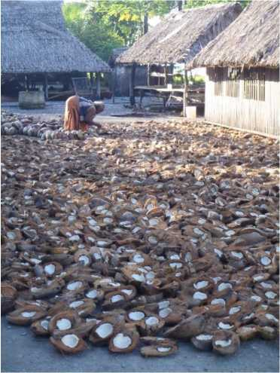

2016-19 Key Priority Area 3: Health

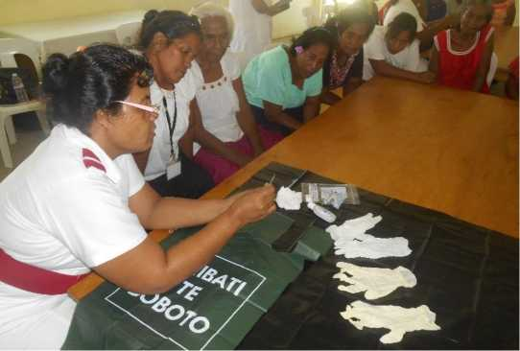

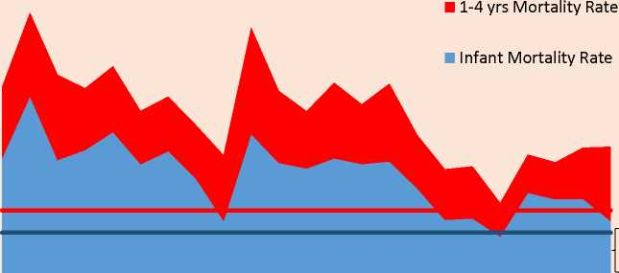

1991 1993 1995 1997 1999 2001 2003 2005 2007 2009 2011 2013

Situation Analysis

Kiribati enters the 2030 UN development agenda with unfinished business regarding many of its health-related Millennium Development Goal targets. Life expectancy at birth in 2013 was 64 for males and 69 for females,[10] the second lowest in the Pacific after PNG.

Its under-five mortality rate (52.9 per 1,000 live births in 2013)[11] is the second highest among the Pacific Island countries after PNG, mainly due to neonatal mortality, malnutrition and common, life-threatening infections (such as pneumonia and diarrhoea). Problems include the lack of skills and capacity of maternal care attendants, particularly in the outer islands and the quality of maternal and child health facilities and equipment. Immunisation rates vary greatly between islands. Neither rotavirus nor pneumococcal conjugate vaccines are currently included in the national schedule.

Figure 9: Infant and Under 5 Mortality Rates, Kiribati, 1991 to 2013

120

100

80

60

40

o  
Q

20 £

in

0

Source: MHMS

The MDG target for maternal mortality[12] in Kiribati was to reduce the rate to 25 by 2015. In 2013, the figure was nil because there were no maternal deaths that year. However, the figure was 150.6 in 2014, a significant variance from the target. The actual number of maternal deaths in Kiribati is quite low (4 in 2015), but due to the small population and relatively low number of live births annually, the figure is multiplied up to calculate a ratio per 100,000 live births, magnifying small variations. The average number of maternal deaths was 3.25 between 2012 and 2015 whereas the average number in the previous four-year period was 1.25.

The 2010 modern methods Contraceptive Prevalence Rate (CPR) was 18 per cent, a drop from 32 per cent in 2005 and 22 per cent in 2007 and is well below the MHMS target of 57 per cent.

Communicable diseases are endemic in Kiribati and most of them are associated with overcrowding and poor hygiene. Access to, and use of, safe water and basic sanitation are the best ways of promoting improved hygiene. However, potable water and sanitation remain large challenges with South Tarawa the biggest concern. Kiribati is one of four countries in the world that still has leprosy.

The incidence of tuberculosis is the highest in the Pacific. It has risen from 116 per 100,000 population in 1990 to a high of 605 in 1997 but has declined steadily since then until 2009. The incidence rate in 2014 was 497. Treatment rates have been declining since 2009. Diabetes is a major driver of the TB epidemic.

Figure 10: Incidence of TB and Treatment Success Rate, Kiribati, 1990-2014

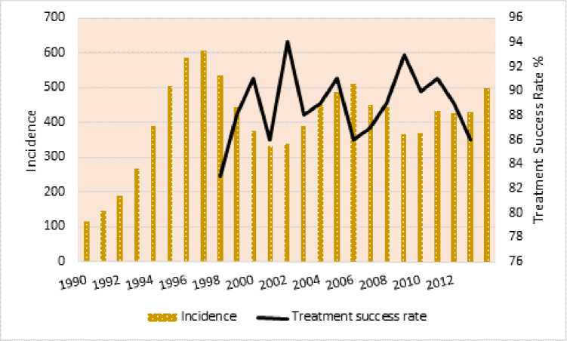

Source:WHO

Non-communicative diseases such as diabetes are also a major cause of death in the Pacific Islands and Kiribati is no exception. Almost three-quarters of the adult population have personal NCD risk factors (elevated blood pressure, smoking, insufficient exercise, andobesity), and one quarter of adults over the age of 25 years are pre-diabetic or already on treatment for diabetes. Data on the incidence of diabetes have not been recorded well in the past but recent information suggests that diabetes continues to be a major health issue. The number of new cases of diabetes fell from 1,036 in 2009 to 809 in 2013 but has risen to an all-time high of 1,123 in 2014 (Figure 11).

Figure 11: Incidence of Diabetes, Kiribati, 2002-14

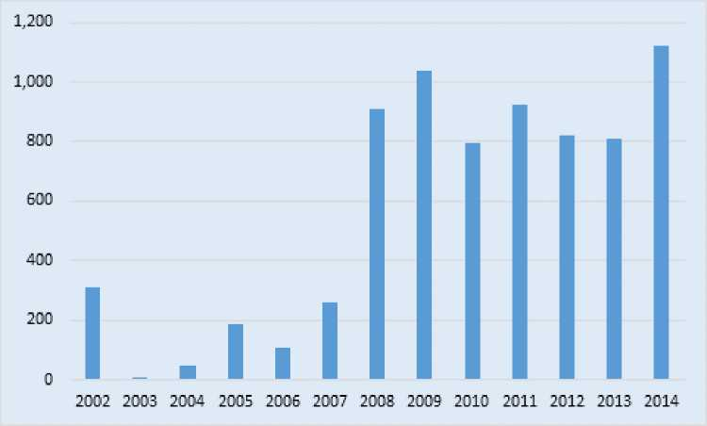

Source: MHMS

Lower limb amputation as a result of diabetes and smoking is the most rapidly increasing reason for surgical admission at the national hospital and contributes significantly to the national burden of disability. Tobacco consumption in Kiribati is the highest in the South Pacific with 61.5 per cent of the population current smokers (74.0 per cent for males and 45.4 per cent for females).

Figure 12: Amputations in Kiribati, 2002 to 2014

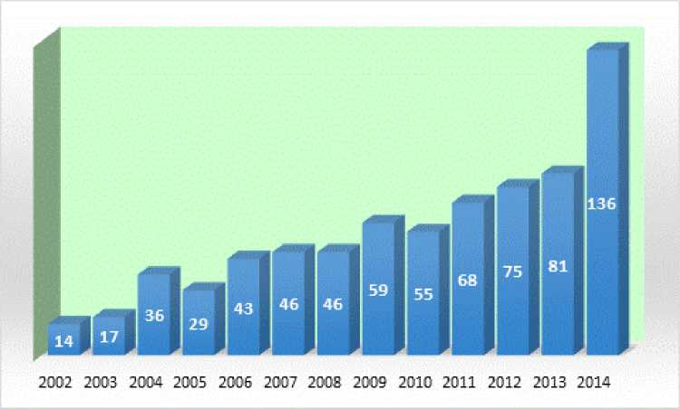

Source: MHMS

The first case of Human immunodeficiency virus (HIV) was diagnosed in 1991 and since then the number steadily increased but has dropped off in more recent years. Kiribati’s incidence of HIV/AIDS was one of the highest in the Pacific. The total number of people ever diagnosed with HIV in Kiribati is 58. No new cases were detected in 2010, 2011 or 2012. There was one new case in 2013 and two new cases in 2014.

Figure 13: New HIV Positive Cases, Kiribati, 1991 to 2014

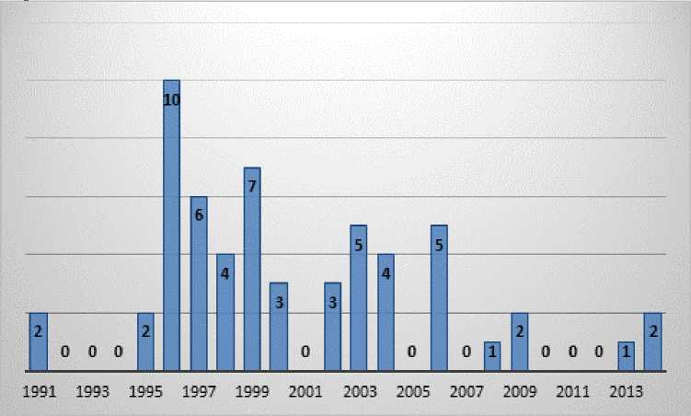

Source: MHMS

There are significant levels of gender-based violence, including towards adolescents and children. The Kiribati Family Health and Support Study published in 2010 showed that violence against women is prevalent. According to the study, 68 per cent ever-partnered women aged 15-49 reported experiencing physical or sexual violence, or both, by an intimate partner.

The disease statistics relating to water, sanitation and hygiene issues are at all-time highs, with more than 35,000 cases annually reported during 2010-2012, including diarrhoea, dysentery, conjunctivitis, rotavirus, giardia and fungal infections such as ringworm[13]. Dysentery and diarrhoea rates in South Tarawa are 350 cases/1000 population annually, including many infants. Kiribati has the second highest rate of under 5-year child mortality in the Pacific, with a reported 60 deaths per 1000 births. In 2010-2012, 16 deaths per year were attributable to water, sanitation and hygiene issues. Unsafe hygiene and sanitation practices are causing contamination of tank water, ground water and lagoon water. Targeted programs need to continue and be strengthened and water quality results need to be monitored more closely and published. The economic burden of poor water and sanitation on South Tarawa alone is estimated to be AUD 3.7-7.3 million, which equates to AUD 550­1,100 per household per annum. This estimate considers the health expenditure for households and government, the loss in economic productivity due to lost time and earning potential, the reduced benefits from tourism and impacts to fisheries.

There is increasing sale of expired products in the market which has become a serious threat to health and safety of consumers. This is attributed to growth in businesses through increase in imported goods, without complementary measures to monitor and effectively enforce the Food Safety Act.

Goals and Strategies

Health plays an important role in economic development for Kiribati. Improved living standards would lead to a healthier population, improved economic performance and a productive future.

The Health Ministry Strategic Plan describes the demographic and socio-economic factors that provide a general context for health service demand in Kiribati. It also provides evidence of the need for action, as well as the main challenges for the health system in meeting these needs, in seven priority areas: non-communicable diseases (NCDs); population growth; maternal and child morbidity and mortality; communicable diseases; health service delivery; and gender-based violence (GBV) and youth issues.

**Goal 3: Improve population health and health equity through continuous improvement in the quality and responsiveness of health services, and by making the most effective and efficient use of available resources**.

Strategies:

* Strengthen initiatives to reduce the prevalence of risk factors for NCDs, and to reduce morbidity, disability and mortality from NCDs through tobacco and alcohol control, healthy eating and physical activities. In additional, prevention, detection and early treatment of cervical cancer, hypertension, heart disease, chronic lung disease, diabetes will be pursued.
* Through the Ministry of Public Works and Utilities, implement a Road Safety Action Plan to ensure that communities enjoy the benefits of improved and safe transport services and that road-related injuries and fatalities are minimised.
* Increase access to and use of high quality, comprehensive family planning services, particularly for women.
* Improve maternal, newborn and child health through care procedures during pregnancy, delivery and the immediate postpartum period and for the newborn; improve the skills and capacity of maternal care attendants; and improve maternal and child health facilities and equipment.
* Prevent the introduction and spread of communicable diseases through strengthening existing control programs on TB, Leprosy, and Lymphatic Filariasis. In addition, new initiatives will be pursued to increase access to, and use of, safe water and basic sanitation services, and promote improved hygiene.
* Improve the effectiveness and efficiency of health service delivery, including through expanding hospitals and clinics to meet demand; develop a formal asset maintenance and replacement programme for infrastructure and equipment; and improve procurement and supply of essential medical products, vaccines and technologies.
* Improve access to high quality and appropriate health care services for victims of gender based violence and services that specifically address the needs of youth, through implementation of the Standard Operating Procedure of Eliminating Sexual 34

and Gender Based Violence (ESGBV) policy and build capacity of health care givers to sensitively handle the needs of victims of GBV.

* Improve sport and physical activity participation particularly for youth and people with disabilities as a means of improving health standards.
* Strengthen the implementation of the Foods Safety Act and establish foods standards to safeguard consumer health and safety

Key Performance Indicators:

1. Declining adult mortality rate from NCDs (30-69 years).
2. Declining number of diabetes related amputations.
3. Declining mortality rate from road traffic injuries - number and rate of deaths per 100,000 population.
4. Declining adolescent birth rate for 10-14 years, 15-19 years per 1,000 girls in that age group.
5. Increased contraceptive contacts (all forms) as seen at health facilities per 1,000 population.
6. Maintaining the number of maternal deaths at zero or as close as possible.
7. Declining neonatal, infant and under 5 years mortality rates per 1,000 live births.
8. Increasing proportion of births attended by skilled health personnel.
9. Increasing or maintaining TB treatment success rate at or above 90%.
10. Achievement of 7 International Health Regulations core capacities for surveillance and response.[14]
11. At least three quarterly health and finance reports produced annually that track progress against core indicators for KHSP implementation.
12. Maintaining at least 40 health workers per 10,000 population.[15]
13. Maintaining at least 80% availability of essential medicines and commodities at primary health care facilities.
14. Meeting the target for the number of outpatient consultations per capita.[16]
15. Increasing proportion of cases dealt with by the Family Health Centre and other health facilities.

2016-19 Key Priority Area 4: Environment

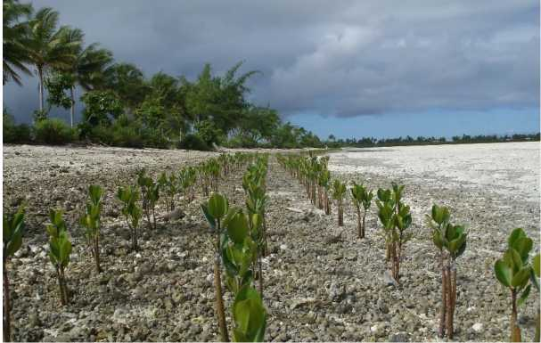

Situation Analysis

There are five key environmental policy areas identified by the Government: climate change; biodiversity conservation and management; waste management and pollution control; resource management; and environmental governance.

The Exclusive Economic Zone (EEZ) of Kiribati is 3.55 million sq km with a distance of 3,500 km from east to west (equivalent to the distance between Los Angles and Washington) and 1,500 from north to south. Land area is a total of 810 sq km. Kiribati is one of the few nations in the world that consists almost entirely of coral atolls which makes it in an extremely vulnerable state to climate change. These sandy islands have few natural resources including water and are prone to drought. As a consequence, traditionally the people have relied heavily on the sea for their livelihood.

New environmental threats that have emerged include pollution of the lagoons, build up of solid waste, depletion of water, pollution of water from salinity and waste products, deforestation, depletion of inshore fisheries and coastal erosion. Marine life is also under threat from pollution and plastic wastes. The spread of invasive species and agricultural pests and diseases, could potentially have a significant impact on the economy of Kiribati. Waste oil and other chemicals contribute to pollution. Litter has become an increasing problem. Hazardous e-waste and bulky waste (of old vehicles) both need managed collection and shipment out of Kiribati.

Population pressures have resulted in overcrowding that is putting stress on housing, land management, crucial public infrastructure and the natural environment including underground water reserves. Deteriorating water quality will also impact on people’s health. The high rate of population growth in South Tarawa is causing stress on water and sanitation services. The migration of more people to Kiritimati Island also puts pressure on the Government with regards to an increasing number of squatters and other land use issues.

The Kiribati Joint Implementation Plan for Climate Change and Disaster Risk Management 2014-2023 (KJIP) sets out a holistic approach to integrate climate change and disaster risks into all sectors. The Plan aims to reduce the vulnerability of the country to the impacts of climate change and disaster risks and to coordinate priorities for action.

Behavioural attitudes towards the environment and limited enforcement of the Environment Act and other environmental-related legislation are also concerns. There is a general lack of understanding among the population of the consequences of actions such as sand mining and over-fishing. However, in many cases, individuals have few alternatives and therefore fail to comply with existing legislation. The growing demand for building materials on South Tarawa for housing, infrastructure and improving coastal resilience will require concerted efforts to use the sustainably extracted supplies of aggregate dredged from the lagoon and to ensure that those who were reliant on sand-mining find alternative productive livelihoods.

Production of copra is inhibited because of the senility of coconut trees along with increasing salinity and declining fertility of the soils.

Kiribati is part of the Polynesia-Micronesia Biodiversity Hotspot. This is among 34 regions of the world where extraordinary levels of biodiversity and endemic species are combined with extremely high levels of threat. The Kiribati Biodiversity Area Report (2013) points out that 90 species found in Kiribati are listed as globally threatened on the *2010 IUCN Red List of Threatened Species[17]*.

A major issue of sustainability in the fishing industry is the protection of marine resources to ensure that the reduction in catch volume associated with overfishing does not occur. In Kiribati from 1 January 2015, the Phoenix Island Protected Area (PIPA) was closed to commercial fishing. PIPA, which makes up 11.3 per cent of the EEZ of Kiribati is the largest marine area on UNESCO’s World Heritage List. PIPA will make a major contribution to ensuring the biodiversity of our region and the maintenance of fishing stocks well into the future.

There is potential for increasing tourism based on the fishing industry, in particular, as well as the abundant bird life on the outer islands. However, nature-based tourism initiatives will require parallel investment in water supply, sanitation, accommodation, energy, transport and telecommunications.

Valuable indigenous knowledge and practices can contribute positively to the sustainable use and effective management of natural resources and the environment and need to be taken into account in formulating policy and strategies.

Climate change is the major long term challenge for small island states, particularly those with coral atolls.

Goals and Strategies

Many environmental issues exist due to the inadequate human, institutional and financial capacity to effectively implement the environmental programs that could lead to improvement in some areas. It is therefore necessary to put more effort and emphasis into the environment and its related sectors to ensure that the environment is healthy and remains liveable for the people of Kiribati.

**Goal 4: To facilitate sustainable development through approaches that protect biodiversity and support the reduction of environmental degradation as well as adapting to and mitigating the effects of climate change.**

Strategies

* Reduce the vulnerabilities to the impacts of climate change and disaster risks through more programs designed to mitigate against climate change and more programs implemented to assist with the adaptation to climate change.
* Increased measures for the adaptation and mitigation of the effects of climate changes including “soft” methods such as the planting of more mangroves.
* Food and nutrition security through increasing crop and livestock diversity and increasing the contribution of agriculture to household income.
* Strengthening the capacity of extension, outreach and information services
* Sustainability in the fishing industry through the protection of marine resources to ensure that overfishing does not result in the reduction in catch volume.
* Biodiversity protected though the identification of pest and disease problems, development and promotion of control methods, and strengthened capacity to respond to pest problems including enhanced border security. This includes compliance with international standards in biodiversity management and enactment of biosecurity legislation.
* Soil management technologies appropriate for atoll conditions developed and adopted.
* A national campaign on waste management for a cleaner environment and better crop nutrition though methods such as utilising piggery wastes for composting.
* Improve and strengthen urban development policies and land planning for sustainable urban growth and private sector development. This includes the management of housing and utilities.
* Increasing nature based tourism to the outer islands through investment in water supply, sanitation, accommodation, energy, transport and telecommunications.
* Investigation of technical solutions to overcome the problems of urban growth and people affected by climate change.
* Measures to enhance waste management policies and pollution control are adopted.
* The viability of sustainable aggregate extraction and processing is maintained and compliance with restrictions on sand-mining is improved.

Key Performance Indicators:

1. Programs for the mitigation of climate change and adaptation to climate change increased.
2. Number of mangrove plantings increased.
3. Crop production, diversity and livestock numbers increased.
4. A new Food and Nutrition Security Policy finalised in 2016.
5. A new Biosecurity Act introduced.
6. Strengthened survey and planning capacity, and improvements in GIS and Data management systems.
7. The number of crop production technologies including hydroponics developed.
8. Number of community agreements developed and signed for the establishment of conservation areas.
9. Stock of fisheries maintained.
10. Number of landfill sites improved.
11. Amount ofbulky scrap metal collected.
12. Urban development policy established.

2016-19 Key Priority Area 5: Governance

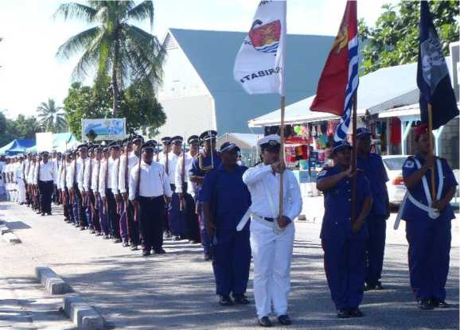

Situation Analysis

Despite development challenges, there are also opportunities. The I-Kiribati people have many strengths. These include a stable participatory democracy; strong community connection; a rich cultural life; many skills in community leadership; community and participatory decision making; rich marine resources; food processing; arts and crafts. There is a high level of participation in community, church and family life as well as a high level of volunteerism in communities. While this creates significant additional labour burdens for women and girls, it also provides opportunities to build on these strengths to work with communities, government, churches, faith based organisations and civil society organisations. With assistance from development partners, the Government is undertaking many activities aimed at decreasing family violence, increasing physical activity, supporting the elderly and youth, and working on national policies for disability and sport. The National Youth Policy requires review and updating and a more coordinated approach to implementing youth development programs.

The state of the Judiciary’s buildings requires an upgrade. There have been no new premises since Colonial times. A new complex is needed to cater for Judicial Officers of the High Court and Magistrates’ Court, archives for both the High Court and Magistrates’ Courts, sheriff’s archives, and a library. A library is a crucial to the justice system to provide the means for Judges, Magistrates, lawyers and the court’s officers to research cases or other legal documents and publications. Security of the premises is also a problem.

For local government, a range of problem areas are required to be tackled. These include poor administrative management of councils which effects service delivery; a lack of transparency and accountability; a lack of capacity of staff; the unavailability of policy and tools for urban management; and a lack of resources for councils to deliver services to communities. Facilities and equipment for councils in the outer islands require upgrading.

Village Banks have not been operating effectively and require a review to provide the necessary micro finance services to outer islands.

For the Police Service, a wide range of initiatives are required to meet the problems facing the force. These include improvements in service (including customer service) and response level to the community; improvements in police/correction skills, supervision and management; the proper maintenance of station/divisional records to keep track and respond efficiently and effectively to irregularities; improvements in data collection (crime data and clearance rate, hotspots, recidivism, road safety, etc), analysis and reporting to provide accurate trends and informed decision-making; improvements in intelligence gathering and analysis through the establishment of a Command centre and other initiatives to provide real­time information to facilitate more efficient and effective decision-making; improvements in police discipline and ethical standards within the organisation; improvements in investigation and prosecution skills and management of cases; the empowerment of the community through community policing initiatives to participate in dispute resolution and crime prevention; addressing domestic violence, sexual abuse and other crimes impacting on women and children. As well, there is a need for the establishment of UN accredited training in peacekeeping operations to facilitate ongoing participation in international policing.

Domestic violence is high. The Kiribati Family Health and Support Study published in 2010 shows that violence against women is prevalent. According to the study, 68 per cent ever- partnered women aged 15-49 reported experiencing physical or sexual violence, or both, by an intimate partner.

The major social issues in Kiribati include family breakdown, which in turn creates further complications such as child maintenance, child custody, and the alarming increase of juvenile cases which are all contributing to poverty. One of the best ways forward suggests that the Government needs to be proactive through Counselling and Advocating Parenting skills which are considered critical in preventing or minimizing social issues, and poverty in Kiribati. The Child, Youth and Family Welfare Act was enacted in 2013 with the emphasis on strengthening and supporting families.

According to the Kiribati National Disabilities Survey carried out in 2005, there were 3,840 people with disabilities, of which 2,122 were male and 1,718 were female. People with disabilities experience discrimination and face barriers to participating and accessing opportunities.

More work is required to lift capacity in the management and delivery of public service programs. The quality of the work of the Kiribati National Audit Office (KNAO) requires improving to be able to undertake performance audits of Ministries and SOEs. Training needs to be undertaken to raise public financial management standards and productivity levels more generally. Improvements in service delivery are required for the public sector to be managed more efficiently and capable of responding to community needs.

While legislation and regulations to monitor the development of cooperatives in Kiribati exist, the full potential of cooperatives in fostering sustainable economic development needs to be harnessed. The sector needs to become more diversified. Other challenges include internal problems related to governance and leadership, inadequate knowledge, management information systems, poor enforcement of existing regulations and lack of a policy to guide the conduct of co-operative development.

The capacity of the Ministry of Labour and Human Resource Development also needs to be strengthened in order to effectively administer the new labour laws to ensure compliance by both Government and private sector.

Local councils have limited supply of funds and require financial security to undertake long­term projects. Part of this security could involve the setting up of Trust Funds to enable councils to use interest payments to supplement recurrent spending and for expenditure on development projects.

Goals and Strategies

The quality and standards of Ministry services requires improvement to protect and enhance the dignity, rights, safety and welfare of Kiribati people. Strong active families and communities, healthy confident young people and children, violence free communities, and access to services for the vulnerable is important for the social growth of the nation.

Obligations for the reporting and implementation of international conventions that have been ratified need to be met.

**Goal 5: To strengthen national governance systems to promote the principles of good governance including accountability, transparency, and inclusiveness.**

Strategies

* Review the Incorporated Societies Act and Religious Bodies Registration legislation and regulations to build a strong NGO sector and support to faith based organisations.
* Continue to actively monitor the implementation and reporting of Kiribati’s obligations under ratified international conventions including the Human Rights Convention, the Convention on the Elimination of all forms of Discrimination against Women (CEDAW), the Convention on the Rights of Persons with Disabilities, the Convention on the Rights of the Child, and the Convention Against Corruption.
* Finalisation and Launching of the Kiribati National Disability Policy.
* Execution of the Kiribati Shared Implementation Plan on eliminating Sexual and Gender Based Violence.
* Support the implementation plan of the Children, Young People and Family Welfare Act 2013 to strengthen the roles of the family Institution as a way to minimize and prevent social issues.
* Formulation of a revised National Youth Policy 2017 to 2021.
* Finalisation and implementation of the National Gender Equality and Women’s Development Policy.
* Improvements in the economic empowerment of women through the conduct of

Women’s Economic Empowerment Training and the development of a manual on Women’s Economic Empowerment for trainers.

* Timely financial audits and performance audits of Ministries and SOEs undertaken by the KNAO.
* Development of a National Cooperative Policy to build the capacity of the cooperative movement through diversifying the range of cooperative enterprises, and promotion of good governance, compliance to laws, regulations and standards.
* Improve the public service governance through adopting transparency and accountability in services delivery by Government employees.
* Implementation and enforcement of the Employment and Industrial Relations Code and the Occupational Health and Safety Act.

Key Performance Indicators:

1. Increased training for Local Council officers.
2. Review of the Village Banks to provide micro finance to the outer islands.
3. Review of the Incorporated Societies Act and Religious Bodies Registration legislation.
4. Review of the National Youth Policy.
5. Finalisation of the Kiribati National Disability Policy.
6. Reduction in the number of domestic violence incidents and reported cases.
7. Endorsement of the Implementation Plan of the Community Outreach Programs on Parenting Skills and Social Welfare.
8. Improvements to the police service.
9. Timely financial and performance audits ofMinistries and SOEs undertaken by the KNAO.
10. High implementation and compliance against all obligations under ratified International Conventions.
11. Finalisation and Endorsement of National Gender Equality and Women Development Policy.
12. Development of a National Cooperative Policy to strengthen Cooperatives and Credit Unions.
13. Number of public service audits carried out.

2016-19 Key Priority Area 6: Infrastructure

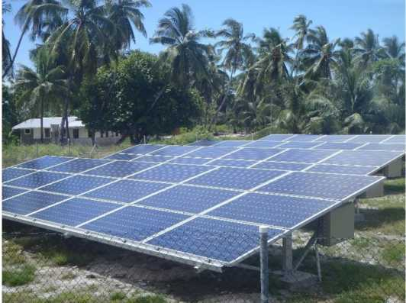

Situation Analysis

Challenges from more frequent king tides and storms due to changing climate patterns have increasingly impacted the coastlines causing physical damage to assets and economic losses to Government and communities. A priority goal therefore is more strategic coastal protection initiatives including identification of vulnerable areas and introducing robust seawall designs to withstand the impacts of rising seas. One of the visible efforts in this direction is the total replacement of the “sandbag” seawall design with a new “mass­concrete” seawall design. Development of and adopting climate change proofing policies and codes for government, public and private buildings are also part of this plan.

The quality and quantity of safe water supply, especially on South Tarawa, are in a critical state where proper and effective intervention is needed now than later. The rain water harvesting system that is promoted and implemented in Kiribati by the Kiribati Adaptation Project Phase III, Water and Sanitation in Outer Islands (Kiriwatsan) and IFAD projects take into aims to increase the quantity of water available during the wet seasons. The use of simple hand pump system is also promoted as an option to improve the quality and quantity from ground water lens. There is an expectation that the use of solar desalination could be a medium term solution for improving the quality and quantity of water from the ground.

Water and Sanitation infrastructure to be built in the outer islands need to be easily maintained through building local communities’ sense of ownership and capacities. The engagement and involvement of the communities during the implementation of the project is one of the options to encourage this sense of ownership and assist them improve their ability to maintain the installed systems in the long term.

Improvement of the water system in Kiritimati Island is progressing under Secretariat of the Pacific Community supervision and funding by the European Union. The system aims to provide enough water for communities living in the villages at Tabwakea, Tennessee and Ronton.

Development of the energy supply infrastructure has occurred under the KDP 2012-15 with a special focus on renewable sources of energy. Figure 14 shows the source of energy outputs for the country.

Figure 14: Share of Energy Output by Source, Kiribati, 2014

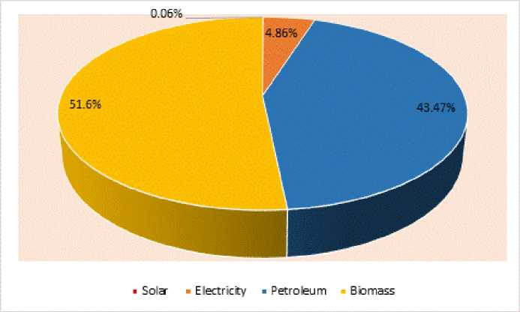

Source: MPWU

By 2016 three new solar photovoltaic systems will be connected to the PUB grid on South Tarawa with an additional peak capacity of 1.4 MW, or 30 per cent of peak demand. These include the Japan-funded 400 kw system, and the UAE-funded 500 kw system. A World Bank funded 516 kw system is to be installed on roof-tops at four sites and commissioned by mid-2016. With automated power management, the systems are expected to provide about 10 per cent of total demand and to save about $800,000 in fuel costs annually.

Pilot trials of renewable energy options will continue on wind generation, coconut oil biofuel, solar-powered water pumps and hybrid mini-grid systems.

Connections of solar power points on the outer islands has been hampered by a number of problems including drought conditions on a number of islands which has affected the life of wet batteries. The installation of batteries which adopt new dry cell technologies will assist with the sustainability of power from solar energy. (See Figure 15).

Figure 15: Solar Connections to Outer Islands, Kiribati, 2004-14

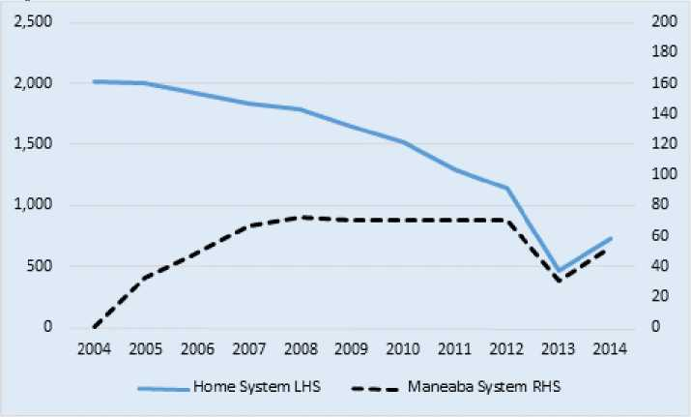

Source: KSEC

Inter-island connectivity is reliant on air and sea services to cover the vast distances of 3,300 km of ocean between the three island groups and to connect the 20 inhabited atolls to the main economic centres on South Tarawa in the west and Kiritimati in the east. Air services are unreliable and serve only the Gilbert group and sea services are unscheduled. A major upgrade of the international airports at Bonriki and Cassidy is in progress, and port expansion in Betio was completed in 2014. Priority now needs to be given to improving the capacity of the port on Kiritimati Island to accommodate regional, fishing and tourism vessels, and the wharves, jetties and airfields on the outer islands. Upgrading of Kanton Island airport in the Phoenix islands would support development of tourism potential and the feasibility of establishing an air link between Tarawa and Kiritimati. Intra-island transport and the provision of social services are hampered by the poor condition or lack of roads and causeways on the outer islands. The economically crucial causeway linking the Betio port and business centre to the rest of Tarawa and the Bonriki airport is at high risk of collapse and in urgent need of major reconstruction.

A Line and Phoenix Integrated Development Strategy is in progress. Implementation of key intervention components will require a number of fundamental planning and development issues to be resolved by Government and the community. These implementation components provide a means to address the priority issues in a systematic manner.

While the number of telephone connections has risen in recent years, Kiribati is one of the least “connected” countries in the world. The number of cellular subscribers per 100 people while rising substantially in recent years was 16.6 in 2013. The number of internet users per 100 people has multiplied dramatically but is still low at 11.5 in 2013. The majority of the population either has no access to information communication technologies (ICT) or unable to afford the service, which is often unreliable. Telecommunications for the Outer Islands requires upgrading especially for the provision of internet services.

Goals and Strategies

The development and maintenance of basic infrastructure to support transport, coastal protection, sanitation and water, and communications are fundamental to economic growth and health of the population. Reliable shipping and air services will contribute to economic development and assist with the potential of tourism, particularly to the outer islands. Development of sustainable energy resources is also fundamental for self-sufficiency and overcoming the burdens of high importation of fuel.

**Goal 6: To improve access to quality climate change resilient infrastructure in urban and rural areas**

Strategies:

* Implement environmentally sustainable causeways in both the urban and rural areas including the completion of the new causeway between Betio and Bairiki.
* Undertake to complete the implementation of the roads and airfields upgrading in the outer islands.
* Identify and improve the infrastructure needs for the Line and Phoenix islands including the sea port and airport facilities on Kanton Island.
* Adoption of strategic coastal protection initiatives including identification of vulnerable areas and the introduction of robust seawall designs.
* Develop policies on environmentally sustainable designs and innovative building construction methods including the application of the Building Codes and full compliance, periodic reviews and update.
* Implement sustainable infrastructure by developing and adopting a comprehensive maintenance plan for major infrastructure.
* Promote and implement the use of safe water from ground and water harvesting and sanitation programmes including the following:
* The South Tarawa Sanitation Improvement Sector Project and the South Tarawa Water and Sanitation Road Map 2011-2030;
* The outer islands Kiriwatsan and IFAD Food and Water Project;
* Installation of hand pumps in most villages on Abaiang under the USAID/SPREP funding;
* Support the completion of the Kiritimati Water Supply project.
* Improve water security for communities through development of water supplies from ground resources and rainwater harvesting, and explore use of solar-powered seawater desalination by reverse osmosis.
* Develop and promote the use of renewable energy in all sectors of the economy including the implementation of the Kiribati Integrated Energy Roadmap.
* Improve operational safety and oversight of international air transport infrastructure through the completion of the Kiribati Aviation Investment Project.
* Improve the inter-island transport system.
* Facilitate improved telecommunications connectivity for the Outer Islands.
* Promote training opportunities for professional and technical staff in relevant ministries including work attachments in local and overseas programmes.
* Upgrade and improve data storage and management and use by staff in Ministries.
* Upgrade and enhance the capacity of ministry professional and support staff in the use

and application of appropriate levels of competency in the information and communication technology.

* Adoption of a medium-term reform plan of the PUB detailing the reform options to achieve operationally and financially sustainable electricity, water, and sanitation services.
* Identify and implement a medium-term reform plan and options to improve the operations and functionality of the Plant and Vehicle Unit.
* Commence the implementation of key components of the Line and Phoenix Integrated Strategy.

Key Performance Indicators:

1. Completion of the new causeway between Betio and Bairiki.
2. Complete roads and airfields upgrading on 8 outer islands under Phase 1 and Phase 2 by end of 2019.
3. Provide technical support for the development and improvement of infrastructure on Kanton Island.
4. Increased number of strategic coastal protection initiatives including the application of mass concrete seawalls.
5. Completion of the South Tarawa Sanitation Improvement Sector Project.
6. Comprehensive maintenance plan for major and critical infrastructures adopted.
7. Increased number of households’ access to potable water.
8. Improve the water system in Kiritimati Island.
9. Increased number of solar energy connections.
10. Three solar photovoltaic systems connected to the PUB grid on South Tarawa by the end of 2016.
11. Energy efficient systems and standards developed and adopted.
12. Increased number of tanks for rain water harvesting.
13. Completion of the Kiribati Aviation Investment Project.
14. Increased rate of use of mobile phones and the internet.
15. Improved telecommunications connectivity for the Outer Islands
16. Adoption of a medium-term reform plan of the PUB.
17. Medium term reform options for the PVU adopted.

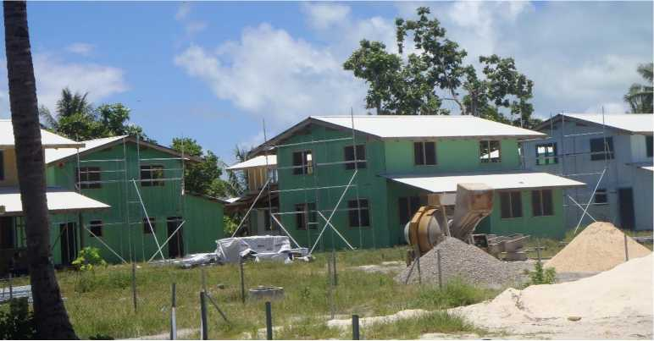

Monitoring and Evaluation for Results

A key strategy of the 2016-19 KDP is the development and implementation of a National Strategy for the Development of Statistics (KPA 2). This will include the development of a centralised national statistical website where all statistical information from all Ministries will be stored.

The National Economic Planning Office will compile an analytical Progress Report of the KDP national performance on a bi-annual basis. At the national level, the Development Coordinating Committee (DCC) will provide quality assurance of the KDP through oversight and approval of these bi-annual progress reports. The Country Results Framework (Annex A) will provide the basis for monitoring the Plan. The performance information presented in the KDP Progress Report will be discussed and assessed by the DCC and decisions will be made in relation to management actions required. The six-monthly Progress Report will then be taken by the DCC to Cabinet. NEPO will also compile an annual summary report of the national performance of the post 2015 Sustainable Development Goals (SDGs). This report will also be assessed by the DCC before being taken to Cabinet.

A Mid-term Review of the KDP will be carried out after two and a half years of the Plan’s operation. The Mid-Term Review in 2018 will measure progress on the implementation of the KDP through consultation with stakeholders and suggest areas of ongoing strengthening to facilitate improved and more efficient implementation. The Mid-Term Review will report to the DCC and ultimately Cabinet. The Mid-Term Review will assist in shaping the framework for the next KDP 2020-2023.

A final evaluation of the KDP will be conducted after four and half years of the Plan’s implementation. The evaluation will be led by NEPO with support from development partners. The underlying principle of the evaluation will be to ensure independence and objectivity. The evaluation will assess the overall effectiveness of the KDP against its objectives, targets, and where possible, it will look at impacts. The evaluation will be considered by the DCC and the Cabinet.

Development partners will assist with the process of monitoring the KDP through the provision of relevant reports such as Project Mid-Term Reviews, Project Completion Reports and participation in the regular Donor Coordination meetings.

Annex A: Country Results Framework for 2016-19

|  |  |  |  |  |  |
| --- | --- | --- | --- | --- | --- |
| **National Results/Outcomes** | **Strategies** | **Key Performance Indicators** | **Target** | **Means of Verification** | **Responsible Ministry** |
| **KDP 1: Human Resource Development Key Objective: Improve the quality of education and training to provide students with the skills and capability to progress to a productive future by 2019** | | | | | |
| Outcome 1: An education | > Lift enrolment and | Net enrolment rate for | 100% | Education Digest | MoE |
| and training system where quality, inclusive, equitable, technical and professional development | participation of 6 year olds in Year 1substantially through promotion of successful early engagement in learning as a critical foundation for further | males and females in primary education  Net Intake Rate for | 100% | Education Digest | MoE |
| opportunities are enhanced. | learning.  > As the critical foundation for  ongoing learning and development, | males and females  Survival Rate for Class | 100% | Education Digest | MoE |
|  | accelerate the transition into English in Primary and Junior Secondary School > Priority will be given to the  further implementation of the National | 5 for males and females  Transition Rate from | 100% | Education Digest | MoE |
|  | Curriculum and Assessment Framework, setting of national benchmarks, providing curriculum resources and writing of new syllabuses | Class 6 to Form 1 for males and females  Reduction of student | 20 | Education Digest | MoE |
|  | > Implement a strategy to  integrate emerging developments in ICT into curriculum and school operations | teacher ratios in primary education.  Proportion of students | 60% in English, 70% in | Education Digest | MoE |
|  | * Provide healthy and safe   school buildings and facilities by reviewing and refocussing the school rehabilitation program in consultation with the Facilities Management Unit and stakeholders.   * Secure ongoing funding for the   delivery of the Primary School and Junior Secondary School (JSS) facilities maintenance schedule | performing at or above the STAKI expected level is raised. | Te-Kiribati and 60% in Numeracy for Class 4 students; 60% in English, Te-Kiribati and Numeracy for Class 6 students. |  |  |

|  |  |  |  |  |  |
| --- | --- | --- | --- | --- | --- |
| **National Results/Outcomes** | **Strategies** | **Key Performance Indicators** | **Target** | **Means of Verification** | **Responsible Ministry** |
|  | * Complete and implement the   regulations flowing from the Education Act 2013.   * Establish collaborative   mechanisms for MoE engagement with government agencies and other non­government education sector stakeholders.   * Establish a more explicit and   sustained focus on the teacher skills needed to transform literacy and numeracy achievement levels in Primary School. |  |  |  |  |
| > Support skills development  amongst teachers and increasing the professionalism of each teacher through lift teacher competencies to meet internationally recognized Teacher Service Standards and implement the Teacher Registration Process as part of strengthening professionalism | The proportion of teachers having the required minimum qualification to teach | 100% | Education Digest | MoE |
| * Effectively implement the   Inclusive Education Policy to target children with disabilities and communicate and gain community acceptance of the policy of mainstreaming children wherever appropriate.   * Strengthen teacher capabilities   to teach to more diverse learning needs and design and develop a supportive and enabling operational environment. | Proportion of students with disability enrolled in mainstream schools | 50% | Education Digest | MoE |
| > Foster the development of  early childhood education through support for the development of an | Proportion of students enrolled in Early Childhood Education | 50% | Education Digest | MoE |

|  |  |  |  |  |  |
| --- | --- | --- | --- | --- | --- |
| **National Results/Outcomes** | **Strategies** | **Key Performance Indicators** | **Target** | **Means of Verification** | **Responsible Ministry** |
|  | appropriate legislative and the development of a supportive operational environment |  |  |  |  |
| > Establish, endorse, and  implement the National Sport Policy | Policy endorsed | Policy endorsed and implemented by 2017 | MWYSA records | MWYSA |
| > Strengthening and enforcing  TVET quality standards so that TVET providers meet regional and international standards including accreditation of KIT with Pacific Regional Qualification Framework > Improve access and entry  opportunities for I-Kiribati into TVET programmes and qualifications through a range of strategies including the development and implementation of an Outer Island and Kiritimati Island strategy and identify opportunities for skills testing and gap training existing workers. | Number and proportion of KIT students completing their training and gaining international quality assured qualifications. | Increased number and proportion | KIT records | MLHRD |
| > Officer of the Watch training  introduced | Program introduced | New program instigated | MTC records | MLURD |
| > Training in port operations  undertaken | Program introduced | New program instigated | MTC records | MLHRD |
| > Strengthening Government’s  workforce capacity to meet the demands for the Government’s services through training programs for employees. | % increase in the number of qualified employees. | 0% qualification gap | Workforce plan analysis | PSO |

|  |  |  |  |  |  |
| --- | --- | --- | --- | --- | --- |
| **National Results/Outcomes** | **Strategies** | **Key Performance Indicators** | **Target** | **Means of Verification** | **Responsible Ministry** |
| **KDP 2: Economic Growth and Poverty Reduction**  **Key Objective: To enhance inclusive economic development through increasing sustainable employment, financial inclusion for vulnerable groups, structural and fiscal reforms and accelerating private sector development by the year 2019** | | | | | |
| Outcome 1: Increased Sustainable economic development and improved standards of living for all I- Kiribati | > Support policies to raise  income levels through various means including enhancing overseas employment opportunities to promote stronger growth in remittances; increasing domestic production especially in the Outer Islands through strengthening existing industries and promoting new industries to boost domestic and external trade levels | Real GDP growth | At least 3% averaged annually | KNSO data | MFED |
| > Promotion of private sector  development including enhancing opportunities for external investors. | Private sector employment growth | At least 20% over the period of the Plan | KPF records | MFED |
| > To provide sustainable  development of sectors where Kiribati has a comparative advantage such as fisheries and coconuts through the implementation of products and export diversification strategies | % increase in Export volumes | Increase | KNSO data | MCIC/  MELAD/ MFMRD |
| > Develop and effectively  implement a Coconut Sector Development Strategy | Strategy produced | Strategy developed and implemented | Strategy document | MCIC |
| > Implementation of an  Investment Policy Framework | Growth in FDI | Increase | KNSO data | MCIC |
| > Development of a National  Trade Policy Framework | National Trade Policy Framework developed and implemented | Policy developed and implemented | Policy document | MCIC |
| > Maintain and build on social  security mechanisms to ensure that the most vulnerable, particularly those that | Reduce the proportion of people of all ages living below the | At least half | KNSO data | MFED |

|  |  |  |  |  |  |
| --- | --- | --- | --- | --- | --- |
| **National Results/Outcomes** | **Strategies** | **Key Performance Indicators** | **Target** | **Means of Verification** | **Responsible Ministry** |
|  | suffer from disasters and climate related extreme events are cared for. | national poverty line in 2006 |  |  |  |
| The number of people living in extreme poverty, currently estimated at less than $1.25 a day | Zero | KNSO data | MFED |
| > Improve revenue through  fisheries license fees through advocating the development of measures in PNA, FfA and WCPFC that will improve economic benefits from tuna for Kiribati while conserving the tuna stock | Increased revenue from fishing licenses | Increased revenue | MFED data | MFED |
| > Creation of employment  opportunities through crewing arrangements with shipping companies and establishment of onshore development of fisheries resources | Increased employment opportunities | Increased employment | MFMRD data and KPF data | MFMRD and KPF |
| > Implementation of the Kiribati  National Labour Migration Policy | Policy implemented | Increase of 100% in overseas employment by 2019. | MLHRD data | MLHRD |
| > Development of Kiribati  workers’ website | Number of hits on website | Increase number of hits over time | MLHRD data | MLHRD |
| > Participation of I-Kiribati  workers in 5 new markets | Participation of I- Kiribati workers in new markets | 5 new markets over the duration of the Plan | MLHRD data | MLHRD |
| Outcome 2: Efficiency and sustainability in Government finances | > Increase taxation and customs  revenue through a range of initiatives including increasing the quality of VAT returns; reducing business and company tax arrears through better compliance and record keeping; self-assessment for business and company tax; and reviewing customs regulations. | Increased taxation revenue through improvements to the taxation and customs systems particularly through better compliance measures. | Increased revenue | MFED data | MFED |

|  |  |  |  |  |  |
| --- | --- | --- | --- | --- | --- |
| **National Results/Outcomes** | **Strategies** | **Key Performance Indicators** | **Target** | **Means of Verification** | **Responsible Ministry** |
|  | > Establish effective financial  public administration including improvements in the forecasting of taxation revenue and expenditure for the annual budget; and conducting reviews of internal process to raise efficiency. | Reviews established to contribute to better public financial management. | Reviews conducted | MFED reviews | MFED |
| > Establish effective debt  management controls including ensuring debt levels are sustainable; and monitoring and ensuring that the debt management policy is adhered to. | Effective debt management controls. | Controls established | MFED information | MFED |
| > Enhance management of the  sovereign wealth fund, the Revenue Equalisation Reserve Fund (RERF), through monitoring the performance of RERF asset managers and the efficient utilisation of RERF assets | Efficient utilisation of the Sovereign Wealth Fund (the RERF) and enhancements in its management. | Increased value of the RERF | MFED information | MFED |
| Outcome 3: Raised efficiency of State Owned Enterprises | > Place State Owned Enterprises  on a more commercial footing including the completion of the rationalisation of the coconut industry; rationalise at least two other SOEs including activities such as privatization, Public Private Partnerships (PPP), mergers or contracting out services; the production of annual Statements of Intent (SOIs) by all SOEs and the production of timely half yearly and annual reports by all SOEs. | Place State Owned Enterprises on a more commercial footing | Profitability of SOEs | MFED data | MFED |
| Outcome 4: Improved information available to the Government including through the production of | > Enhance the collection and  availability of statistics through the development and implementation of a National Strategy for the Development of Statistics. This will include the | Production of a National Strategy for the Development of Statistics. | National Strategy for the Development of Statistics adopted. | MFED website | MFED and MCTTD |

|  |  |  |  |  |  |
| --- | --- | --- | --- | --- | --- |
| **National Results/Outcomes** | **Strategies** | **Key Performance Indicators** | **Target** | **Means of Verification** | **Responsible Ministry** |
| accurate and timely statistics | development of a centralised national statistical website; undertaking a Household Income and Expenditure Survey; conducting the analysis of the 2015 Kiribati Population Census; and undertaking a Demographic and Health Survey; improve the data collection and management from Birth, Marriage and Death Registrations and improve the collection of health and education statistics | Development of a centralised national statistical website. | Whole of Government statistical collections on MFED website |  |  |
| > Strengthen fishery and catch  management data | Establishment of an integrated fisheries information management system | System produced | MFMRD data | MFMRD |
| Outcome 5: Enhanced delivery of public service through effective use of development budget funds | > Ensuring aid effectiveness  through improving aid coordination and donor harmonisation; Compiling six monthly KDP Progress Reports and annual Sustainable Development Goals (SDG) Reports; undertake biennial Development Partners’ Forum and biennial UN Joint Strategy Meetings; maintain a comprehensive database of projects; and providing support for monitoring of development projects. | Improvements in aid effectiveness. | Reports produced | MFED website | MFED |

|  |  |  |  |  |  |
| --- | --- | --- | --- | --- | --- |
| **National Results/Outcomes** | **Strategies** | **Key Performance Indicators** | **Target** | **Means of Verification** | **Responsible Ministry** |
| **KDP 3: Health**  **Key Objective: To improve population health and health equity through continuous improvement in the quality and responsiveness of health services, and by making the most effective and efficient use of available resources by 2019** | | | | | |
| Outcome 1: Strengthened initiatives to reduce the prevalence of risk factors for NCDs, and to reduce morbidity, disability and mortality from NCDs. | > Reduce the prevalence of risk  factors for NCDs, and reduce morbidity, disability and mortality from NCDs through tobacco and alcohol control, healthy eating and physical activities. In additional, prevention, detection and early treatment of cervical cancer, hypertension, heart disease, chronic lung disease, diabetes will be pursued. | Adult mortality rate from NCDs (30-69 years) | Declining rate | KHIS and MS1 | MHMS |
| Number of diabetes related amputations | Declining number | KHIS | MHMS |
| Outcome 2: Increased access to and use of high quality, comprehensive family planning services, particularly for vulnerable populations including women whose health and wellbeing will be at risk if they become pregnant | > Increased access to and use of  high quality, comprehensive family planning services, particularly for women. | Adolescent birth rate for 10-14 years, 15-19 years per 1,000 girls in that age group | Declining rate | KHIS and MS1 | MHMS |
| Contraceptive Use: Contraceptive contacts (all forms) as seen at health facilities per 1,000 population | Increased number of contacts | KHIS and MS1 |  |
| Outcome 3: Improved maternal, newborn and child health. | > Improve maternal, newborn  and child health through care procedures during pregnancy, delivery and the immediate postpartum and for the new-born; improve the skills and capacity of maternal care attendants; and improve maternal and child health facilities and equipment. | Maternal deaths | < zero deaths annually or as close as possible | KHIS and MS1 | MHMS |
| Neonatal, Infant and Under 5 years’ mortality rates per 1,000 live births | Declining rates | KHIS and MS1 |  |
| Proportion of births attended by skilled health personnel | Higher proportion | KHIS and MS1 | MHMS |

|  |  |  |  |  |  |
| --- | --- | --- | --- | --- | --- |
| **National Results/Outcomes** | **Strategies** | **Key Performance Indicators** | **Target** | **Means of Verification** | **Responsible Ministry** |
| Outcome 4: Prevention of the introduction and spread of communicable diseases, strengthened existing control programmes and ensuring Kiribati is prepared for any future outbreaks | > Prevent the introduction and  spread of communicable diseases through strengthening existing control programs on TB, Leprosy, and Lymphatic Filariasis. In addition, new initiatives will be pursued to increase access to, and use of, safe water and basic sanitation services, and promote improved hygiene. | TB treatment success rates | Increasing the rate or maintaining it at or above 90% | KHIS and MS1 | MHMS |
| Outcome 5: Gaps in health service delivery are addressed and the pillars of the health system are strengthened | > Improve the effectiveness and  efficiency of health service delivery, including through expanding hospitals and clinics to meet demand; develop a formal asset maintenance and replacement programme for infrastructure and equipment; and improve procurement and supply of essential medical products, vaccines and technologies. | Achievement of 7 International Health Regulations core capacities for surveillance and response | Core regulations present | Six-monthly survey | MHMS |
| Number of quarterly health and finance reports produced that track progress against core indicators for KHSP implementation | At least 3 reports annually | Data from Health Information Unit and Finance Unit |  |
| Number of health workers per 10,000 population | Maintaining at least 40 health workers per 10,000 population | MHMS ER and MFED data | MHMS and MFED |
| Availability of essential medicines and commodities at primary health care facilities. | Maintaining at least 80% availability of essential medicines | A small random survey every 6 mths to look at the proportion of PHCs reporting no more than 2 months out of stock of no more than 2 of an essential list of 10 medicines | MHMS |

|  |  |  |  |  |  |
| --- | --- | --- | --- | --- | --- |
| **National Results/Outcomes** | **Strategies** | **Key Performance Indicators** | **Target** | **Means of Verification** | **Responsible Ministry** |
|  |  | Number of outpatient consultations per capita | 5 annually | KHIS and MS1 |  |
| Outcome 6: Improved access to high quality and appropriate health care services for victims of gender based violence, and services that specifically address the needs of youth. | > Improve access to high quality  and appropriate health care services for victims of gender based violence and services that specifically address the needs of youth, through implementation of Standard Operating Procedure of Eliminating Sexual and Gender Based Violence (ESGBV) policy and build capacity of health care givers to sensitively handle needs of victims of GBV. | Increased proportion of cases dealt with by the Family Health Centre and other health facilities | Increased proportion | KHIS and MS1 | MHMS |
| Outcome 7: Strengthened road safety awareness | > Road safety action plan targets  achieved | Mortality rate from road traffic injuries - number and rate of deaths per 100,000 population | Declining rate | MHMS records | MICTTD, MPWU and MHMS |

|  |  |  |  |  |  |
| --- | --- | --- | --- | --- | --- |
| **National Results/Outcomes** | **Strategies** | **Key Performance Indicators** | **Target** | **Means of Verification** | **Responsible Ministry** |
| **KDP 4: Environment**  **Key Objective: To facilitate sustainable development through protection of biodiversity, support to the reduction of environmental degradation and the mitigation of the effects of climate change by the year 2019** | | | | | |

|  |  |  |  |  |  |
| --- | --- | --- | --- | --- | --- |
| Outcome 1: To strengthen national capacity to effectively respond to the impacts of global climate change | > Reduce the vulnerabilities to  the impacts of climate change and disaster risks through more programs designed to mitigate against climate change and more programs implemented to assist with the adaption to climate change. | Number of programs to mitigate against climate change and number of programs to assist with adaptation to climate change | Increased numbers | OB, MELAD, MFED records | OB, MELAD, MFED |
| > Increased measures for the  adaptation and mitigation of the effects of climate change including “soft” methods such as the planting of more mangroves | Number of mangroves planted | Increased number | MELAD records | MELAD |
| Outcome 2: Promotion of food and nutrition diversity | * Food and nutrition security   through increasing crop and livestock diversity and increasing the contribution of agriculture to household income   * Strengthening the capacity of   extension, outreach and information services | Crop production and diversity and livestock numbers increased | Increase in production | MELAD records | MELAD, MCIC |
| A new Food and Nutrition Security Policy finalised in 2016 | Policy adopted | Cabinet decision | MELAD |
| The number of crop production technologies including hydroponics developed | Increased number | MELAD records | MELAD |
| Outcome 3: Improvements in biodiversity including pest and disease problems identified, control methods developed and promoted, and capacity to respond to pest problems strengthened | > Biodiversity is protected  though the identification of pest and disease problems, development and promotion of control methods, and strengthened capacity to respond to pest problems including enhanced border security. This includes compliance to international standards in biodiversity | Biosecurity bill developed and implemented | Bill enacted | Parliament decision | MELAD |
| Number of community agreements developed and signed for the establishment of conservation areas. | Increased number | MELAD records | MELAD |

|  |  |  |  |  |  |  |  |
| --- | --- | --- | --- | --- | --- | --- | --- |
| **National Results/Outcomes** | **Strategies** | **Key Performance Indicators** | **Target** | **Means of Verification** | | **Responsible Ministry** | |
|  | management and enactment of biosecurity legislation.  > Soil management technologies  appropriate for atoll conditions developed and adopted. A national campaign undertaken on waste management for a cleaner environment and better crop nutrition though methods such as utilising piggery wastes for composting |  |  | |  | |  |
| > Sustainability in the fishing  industry through the protection of marine resources to ensure that the there is no loss of catch volume associated with overfishing. | Stock of fisheries maintained | Sustainable levels achieved | | FFA information | | MFMRD |
| Outcome 4: Enhanced measures to address land development issues | > Improve land planning  arrangements to be able to cater for sustainable urban growth | Strengthened survey and planning capacity, and improvements in GIS and Data management systems | Improvements in GIS and data management systems | | MELAD records | | MELAD |
| Outcome 5: Behavioral change through education, awareness raising and research that promotes best waste management and pollution prevention practices | > Measures to enhance waste  management policies and pollution control are adopted | Number of landfill sites improved. | Number of improved sites | | MELAD records | | MELAD |
| Waste recovery facility is managed. | Amount of bulky scrap metal collected | | MELAD records | | MELAD |
| Outcome 6: Improved quality of the environment in urban areas | > Urban development policy  established. | Policy approved | Policy approved by 2018 | | Cabinet records | | MIA |

|  |  |  |  |  |  |
| --- | --- | --- | --- | --- | --- |
| **National Results/Outcomes** | **Strategies** | **Key Performance Indicators** | **Target** | **Means of Verification** | **Responsible Ministry** |
| **KDP 5: Governance**  **Key Objective: To strengthen national governance systems so as to promote the principles of good governance including accountability, transparency, and inclusiveness by the year 2019** | | | | | |
| Outcome 1: National governance systems improved to promote the principles of good governance including accountability, transparency, and inclusiveness | Increased training and resources for Local Council officers | Number of training sessions carried out to raise the capacity of staff and increase policy documentation and tools for urban management | Increased number | MIA records | MIA |
| > Review of the Village Banks to  provide micro finance to the outer islands | Review undertaken | Review completed by 2019 | MIA records | MIA |
| > Review of the National Youth  Policy | Review undertaken | Review completed by 2017 | MWYSA records | MWYSA |
| > Finalisation and Launching of  the Kiribati National Disability Policy | Policy finalised | Policy launched by 2017 | MWYSA records | MWYSA |
| > Reduction in the amount of  domestic violence | Domestic violence reduced | Large reductions in the rate by 2019 | Police records, records of women’s shelters, surveys | MWYSA |
| > Endorsement of the  Implementation Plan of the Community Outreach Programs on Parenting Skills and Social Welfare. | Implementation Plan endorsed | Implementation Plan endorsed by 2017 | MWYSA records | MWYSA |
| > Finalisation and Endorsement  of National Gender Equality and Women Development Policy. | Finalisation and endorsement of the Policy | By 2017 | MWYSA records | MWYSA |
| > Development of a National  Cooperative Policy to strengthen Cooperatives and Credit Unions. | Policy developed and approved | By 2018 | MCIC records | MCIC |
| > Performance audits of  Ministries and SOEs undertaken by the KNAO | Number of performance audits carried out | Increased number | KNAO records | KNAO |

|  |  |  |  |  |  |
| --- | --- | --- | --- | --- | --- |
| **National Results/Outcomes** | **Strategies** | **Key Performance Indicators** | **Target** | **Means of Verification** | **Responsible Ministry** |
|  | > Improvements to the police  service including response levels; correction skills; the proper maintenance of records; data collection; analysis and reporting; intelligence gathering and analysis through the establishment of a Command centre; discipline and ethical standards; investigation and prosecution skills and case management; community dispute resolution and crime prevention; addressing domestic violence. | Service level improvements | Improvement measured annually | Police records | KPPS |
| > Meet and monitor the  implementation of Kiribati’s obligations under ratified international conventions including the Human Rights Convention, the Convention on the Elimination of all forms of Discrimination against Women (CEDAW), the Convention on the Rights of Persons with Disabilities, the Convention on the Rights of the Child, and the Convention Against Corruption | Obligations carried out | All reporting obligations under international conventions carried out | MWYSA records | MWYSA |
| > Review the Incorporated  Societies Act and Religious Bodies Registration legislation and regulations to build strong NGO sector and support to faith based organisations | Review carried out | Review completed | MWYSA records | MWYSA |
| > Improve the public service  governance through adopting transparency and accountability in services delivery by Government employees | Number of public service audits carried out | Completion of UNCAC review | Review reports | PSO |

|  |  |  |  |  |  |
| --- | --- | --- | --- | --- | --- |
| **National Results/Outcomes** | **Strategies** | **Key Performance Indicators** | **Target** | **Means of Verification** | **Responsible Ministry** |
| **KDP 6: Infrastructure**  **Key Objective: To improve access to quality infrastructure in urban and rural areas including the development of new infrastructure including water and sanitation, energy, shipping, airports and roads by the year 2019** | | | | | |
|  | > Completion of the new  causeway between Betio and Bairiki | Completed causeway | Causeway completed by 2019 | Causeway Project Completion Report | MPWU |
| Outcome 1: Improve access to quality climate change resilient infrastructure in urban and rural areas | > Outer island roads and airfields  upgraded | Number of OI roads and airfields upgraded | Total of 10 islands completed | MPWU records | MPWU |
| > Improve the Kanton airfield  and port facilities | Airfield and port facilities improved | Kanton runway and port used | MPWU, PIPA records | MPWU, MTTCD |
| > Increased number of strategic  coastal protection initiatives | Number of new coastal protection initiatives completed | Increased number and length of coast line protected | MPWU records | MPWU |
| > Maintenance plan for major  infrastructures developed and adopted | Maintenance plan for major infrastructures adopted | Maintenance costs included in annual budgets | MPWU, annual budgets | MPWU |
| > Completion of the South  Tarawa Sanitation Improvement Sector Project | STSISP completed | STSISP completed by 2017 | Project Completion Report | MPWU |
| > Renewable energy systems  tested and installed | A number of solar, bio­fuel, mini-grid and wind energy systems installed | Increase in level of output from renewable energy sources (Kw) | MPWU reports | MPWU |
| > Three solar photovoltaic  systems connected to the PUB grid on South Tarawa by the end of 2016 | GRID systems completed | GRID systems completed by the end of 2016 | Project Completions Reports | MPWU, PUB |
| > Energy efficient systems and  standards developed and adopted. | Energy efficient standards adopted | Minimum standards and energy labelling regulations adopted | MPWU, Cabinet decisions. | MPWU |
| > Develop and adopt a fuel  supply contract based on internationally acceptable standards | Fuel supply contract concluded and adopted | New fuel supply contract signed | KOIL records | KOIL |
| > Increased number of solar  energy connections | Number of solar energy connections | Increased number of households connected | KSEC records | KSEC |

|  |  |  |  |  |  |
| --- | --- | --- | --- | --- | --- |
| **National Results/Outcomes** | **Strategies** | **Key Performance Indicators** | **Target** | **Means of Verification** | **Responsible Ministry** |
|  | > Increased number of  households’ access to potable water | Number of new tanks for rain water harvesting installed | Increased number of rain water tanks | MPWU records | MPWU, MIA |
| Number of hand pumps installed | Increase in number | MPWU and  Council records | MPWU, MIA |
| > Completion of the Kiribati  Aviation Investment Project | KAIP completed | KAIP completed by 2017 | Project Completion Report | MPWU |
| > Improved quality,  sustainability and efficiency in the delivery of services for power, water and sewerage for the people of South Tarawa at affordable tariffs. | PUB reforms carried out | Adoption of a medium­term reform plan | Report | PUB |
| > Improve the operational and  functionality of the PVU | PVU operations reviewed and reformed | PVU new structure adopted | MPWU report | MPWU |
| > Improved water distribution  services in Kiritimati. | Rates of water distribution | Increased rate | MPWU records | MPWU |
|  | > Increased rate of usage of  mobile phones and the internet | Rates of usage | Increased rates | World Bank data | MICTTD |
|  | > Improved telecommunications  connectivity for the Outer Islands | Number of islands connected | Increased number | MICTTD records | MICTTD |

Annex B: The Link between the KDP, Sustainable Development Goals, Istanbul Plan of Action, SIDS Accelerated Modalities of Action (SAMOA) Pathway and the Framework for Pacific Regionalism

|  |  |  |  |  |
| --- | --- | --- | --- | --- |
| **Kiribati Development Plan** | **Sustainable Development Goals** | **Istanbul Plan of Action** | **SIDS Accelerated Modalities of Action (SAMOA Pathway)** | **Framework for Pacific Regionalism (2015 Forum meeting priorities)** |
| **KPA 1: Human Resource Development** | Goal 4: Ensure inclusive and equitable quality education and promote lifelong learning opportunities for all | Human and social development - education and training and youth development | Investment in all forms of education and training for decent work for all |  |
| **KPA 2: Economic Growth and Poverty Reduction** | Goal 1: End poverty in all its forms everywhere  Goal 2: End hunger, achieve food security and improved nutrition and promote sustainable agriculture  Goal 8: Promote inclusive and sustainable economic growth, employment and decent work for all  Goal 10: Reduce inequality within and among countries | Trade (not an explicit target area in KDP)  Economic shocks - global impact on prices, currency, remittances, FDI, tourism  Social protection | Sustained and sustainable, inclusive and equitable economic growth with decent work for all  Food security and nutrition | Increasing economic returns from fisheries resources |
| **KPA 3: Health** | Goal 3: Ensure healthy lives and promote well-being for all | Population and primary health | Health and non-communicable diseases | Substantial burden that cervical cancer places on women and girls in the Pacific region |

|  |  |  |  |  |
| --- | --- | --- | --- | --- |
| **Kiribati Development Plan** | **Sustainable Development Goals** | **Istanbul Plan of Action** | **SIDS Accelerated Modalities of Action (SAMOA Pathway)** | **Framework for Pacific Regionalism (2015 Forum meeting priorities)** |
| **KPA 4: Environment** | Goal 11: Make cities inclusive, safe, resilient and sustainable  Goal 12: Ensure sustainable consumption and production patterns  Goal 13: Take urgent action to combat climate change and its impacts  Goal 14: Conserve and sustainably use the oceans, seas and marine resources  Goal 15: Sustainably manage forests, combat desertification, halt and reverse land degradation, halt biodiversity loss | Agriculture, food security and rural development  Climate change and environment sustainability  Disaster risk reduction | Disaster risk reduction  Climate change  Oceans and seas  Sustainable production and consumption  Biodiversity  Invasive alien species Management of waste and chemicals | Ensuring the sustainable management of fisheries Climate change remains the single greatest threat to the livelihood, security and well­being of the peoples of the Pacific |
| **KPA 5: Governance** | Goal 5: Achieve gender equality and empower all women and girls  Goal 16: Promote just, peaceful and inclusive societies | Gender equality and empowerment of women  Good governance at all levels | Gender equality and empowerment of women  Social development |  |
| **KPA 6: Infrastructure** | Goal 6: Ensure access to water and sanitation for all | Productive capacity - infrastructure; energy; and technology | Sustainable energy | Unprecedented economic and educational opportunities that Information Communications Technologies (ICT) offers, |

|  |  |  |  |  |
| --- | --- | --- | --- | --- |
| **Kiribati Development Plan** | **Sustainable Development Goals** | **Istanbul Plan of Action** | **SIDS Accelerated Modalities of Action (SAMOA Pathway)** | **Framework for Pacific Regionalism (2015 Forum meeting priorities)** |
|  | Goal 7: Ensure access to affordable, reliable, sustainable and modern energy for all Goal 9: Build resilient infrastructure, promote sustainable industrialization and foster innovation | Water and sanitation | Water and sanitation  Sustainable transport | including access to world markets and global knowledge |
| **Means of Implementation** | Goal 17: Revitalize the global partnership for sustainable development | Mobilizing financial resources for development and capacity-building (domestic revenue, ODA, external debt, FDI, remittances) | Means of implementation, including: a) Partnerships; b) Financing; c) Trade; d) Capacity Building; e) Technology; f) Data and Statistics; g) Institutional Support for SIDS |  |

1. Kiribati Population Census 2010, KNSO
2. UNDP, Human Development Report. 2014.
3. [www.mfed.gov.ki](http://www.mfed.gov.ki/) under “Publications”. The progress against the Millennium Development Goals is also available on this website.
4. The 2011 Annual Report for the Ministry of Health and Medical Services notes that “In the years 2006 to 2009 there is a dramatic decrease in mortality however this was when the reporting tools changed and this is the likely reason for the decrease”.
5. GPI based on gross enrolment rates for males and females. Enrolment rates have been withheld from this report due to difficulties estimating the school aged population. Refer to the Kiribati Education Digest 2014 for further details.
6. Analysis of the 2006 Household Income and Expenditure Survey, Kiribati
7. Analysis of the 2006 Household Income and Expenditure Survey, Kiribati
8. Kiribati Population Census 2010, KNSO
9. World Bank 2015
10. WHO, Global Health Observatory Data Repository
11. MHMS
12. The number of maternal deaths per 100,000 live births
13. Activity Design Document: Kiribati Water, Sanitation and Hygiene (WASH) Sector Programme
14. WHO defines this indicator as the percentage of attributes of core capacities that have been attained at a specific point in time (WHO suggests this output indicator is assessed six monthly via a key informant survey). The 7 core capacities for Kiribati based on the Healthy Island Core Indicators are: (1) Surveillance; (2) Response; (3) Preparedness; (4) Risk communication; (5) Human resources; (6) Laboratory; and (7) Points of entry.
15. Using WHO definition of doctors, nurses and midwives
16. This measure is a proxy indicator for accessibility and utilisation of health services that may also reflect the quality of services provided. However, it does not measure the coverage of this service, but the average number of visits in a defined population. Low rates indicate poor availability and quality of services. Further, research has shown a close relationship between the number of doctor consultations and life expectancy, with consultation rates highest in countries with highest life expectancy. In OECD countries, the average number of consultations per capita is about six. A proposed WHO benchmark for developing countries is five consultations per capita per year.
17. [www.iucnredlist.org](http://www.iucnredlist.org)